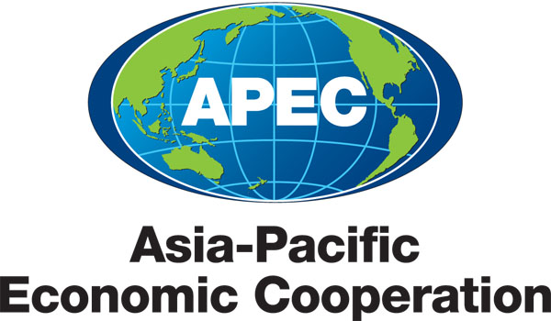
___________________________________________________________________________
2011/SOM1/SCE-COW/017
Agenda Item: 4.1

Telecommunications and Information Working Group (TELWG) Proposed Workplan for 2011

Purpose: Consideration

Submitted by: TELWG Chair

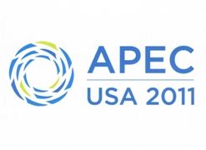 | SOM Steering Committee on Economic and Technical Cooperation - Committee of the Whole Meeting  Washington, D.C., United States  9 March 2011

Proposed Workplan for 2011
Telecommunications and Information Working Group (TELWG)

- Proposed Work Plan for 2011 in Response to Leaders/Ministers/SOM/SCE Priorities and Decisions, and to ABAC recommendations.

The TELWG will work towards the following Leaders/Ministers/SOM Priorities and Decisions and ABAC recommendations for 2011:
- Develop ICT to Promote New Growth
  - Expand networks to achieve universal access to broadband in all APEC economies by 2015；
  - Identify and disseminate strategies to assist developing economies to deploy broadband networks;
  - Encourage economies to develop and implement strategies to make ICT more accessible to people with special needs;
  - Promote public and private sector adoption of IPv6 infrastructure through information sharing and technological collaboration. Develop and promote guidelines to assist economies to effectively transition to IPv6;
  - Provide a platform for information exchange and the development of best practice approaches for efficient infrastructure sharing within economies.

- Enhance Socio-Economic Activities through the use of ICT
  - Share information and promote cooperation among economies to facilitate the introduction of advanced and emerging technologies and services such as cloud computing and grid computing;
  - Develop and promote ICT applications such as smart and resilient grids and sensor networks;
  - Share best practices for ICT applications.

- Promote a Safe and Trusted ICT Environment
  - Promote the development and dissemination of strategies for fostering a safe and trusted ICT environment, with a focus on consumer protection policies that protect personal information and promote the security of networked systems;
  - Promote the development of effective cyber security initiatives, in accordance with the APEC Cybersecurity Strategy and the APEC Strategy to Ensure Trusted, Secure and Sustainable Online Environment, including through distribution of best practice approaches, information sharing, technical cooperation, training and education;
  - Promote and build capacity to implement effective cyber security awareness initiatives, and integrate these into broader APEC activities where possible. In particular, economies will aim to collaborate by holding an annual APEC Cyber Security Awareness Day;
  - Collaborate with all relevant stakeholders, including the Internet technical community, Internet Service Providers and telecom operators, to develop options for effective cyber security initiatives against cyber threats;
  - Share information and promote policies for the protection of vulnerable groups, particularly children, from online threats. For example, by implementing capacity building initiatives that may assist economies in the efforts of ensuring a safe and secure online environment;
  - Foster a secure, safe and productive Internet economy by promoting information exchange.

- Promote Regional Economic Integration
  - Develop ICT policy and regulatory frameworks that facilitate free and open trade arrangements within the APEC region;
  - Increase economies’ participation in the Mutual Recognition Arrangement (MRA) for conformity assessment and implement the MRA for equivalence of technical requirements;
  - Provide capacity building for APEC policy makers and regulators to promote competition and transparency in areas such as interconnection and international mobile roaming markets;
  - Encourage deployment of infrastructure and mechanisms to reduce excessive costs of interconnectivity, including through increasing industry competition by promoting free and open trade and investment;
  - Improve consumer awareness of communications complaint handling mechanisms, service prices and substitute technologies through the publication of reports and other awareness raising activities;
  - Encourage economies to actively participate in TEL projects and exchange knowledge and experience to facilitate streamlined regulatory measures that encourage competition and investment in the market;
  - Enhance submarine cable protection by consolidating and disseminating information that will reduce the incidence of disruption and expedite submarine cable repairs.

- Strengthen Cooperation in the ICT Sector
  - Continue to collaborate with other APEC fora to enhance coordination of ICT related activities within APEC. We also encourage TEL to enhance cooperation with other international organizations such as the ITU, APT, OECD and Internet-related technical and administrative bodies to enhance outcomes and remove any duplication of efforts.

- Anticipated Activities and/or Proposed Work Plan with outside organisations in response to Leaders’ and Ministers’ calls for greater engagement with:
A) Business Sector; and
- Other Organisations/Stakeholders, including the IFIs and other International Organisations

Enhance outcomes and minimise duplication of efforts by collaborating with relevant multilateral organisations including OECD, APT, and ITU, and internet-related technical and administrative bodies on issues such as:
  - developing, implementing and promoting relevant cyber security initiatives;
  - reducing international communication costs;
  - addressing relevant environmental challenges.

- Identify cross cutting issues and explain how they will be coordinated across Fora.
Enhance coordination of ICT related activities with other APEC fora, including:
  - the Committee on Trade and Investment (CTI) by submitting an annual update on progress towards adopting and implementing the WTO Reference Paper
  - the Electronic Commerce Steering Group and the Counter Terrorism Taskforce to promote a trusted ICT environment;
  - the Health Working Group to identify effective e-Health applications;
  - the Emergency Preparedness Working Group to promote the benefits of using ICT for emergency preparedness and disaster prevention/mitigation.

- Expected Outcomes/Deliverables For 2011.
To achieve the proposed work plan for 2011 mentioned in part 1，the TELWG will be undertaking the projects outlined in the following table:

Project No. | Project Name | Overseeing Economy
DSG | APII Test Bed Project | Korea
DSG | APII IPv6 R&D Test Bed Network Project | Japan
DSG | APEC e-Government Research Centre | Japan
DSG | Disaster Management Seminar | Japan
DSG/LSG | Demand based policy approaches to foster universal broadband access | Chile
DSG/LSG | Enabling Information Communications Technology Investment for Growth and Recovery | USA
DSG/LSG | Workshop on Infrastructure Sharing to Foster Broadband Access | China
DSG | Study Workshop on Best Practices Transfer of Green ICT for Sustainable Growth | Thailand
DSG | Smart ICT Application Initiative: Green ICT Seminar – ICT application in the field of environment | Japan
DSG/SPSG | Deployment of Disaster Information Distribution System and Service Model based on NGO Exemplar Platform | Chinese Taipei
DSG | Enhancing broadband development and internet usages for improving networks and services in APEC member economies. | Peru
SPSG | Submarine Cable Protection Information Sharing | Australia
SPSG | Handheld Mobile Device Security | Malaysia
SPSG | Bi-lateral Cybercrime Legislative Drafting | USA
SPSG | Cyber Security Awareness Raising | Australia/USA
SPSG | PKI/e-Authentication Training Program | Chinese Taipei
SPSG | 2nd APEC Seminar on Protection of Cyberspace from Terrorist Use and Attacks (Joint Project from CTTF) | Korea
SPSG | APEC Training Program for Preventive Education on ICT Misuse | Korea
SPSG | Cyber Security Voluntary Internet Service Provider Codes of Practice | Australia
SPSG | Capacity Building within the Asia-Pacific Region in the Prevention of Child Sexual Exploitation Facilitated through the Internet | Australia
SPSG | APEC Workshop on Cybersecurity policy developments in the APEC Region | USA
SPSG | DNSSEC Seminar | Malaysia
LSG | International mobile roaming training for Asia-Pacific regulatory authorities | Australia
LSG | Capacity Building on Telecommunications Trade Rules and Regulatory Disciplines | Singapore
LSG | APEC IPEG: Workshop on Effective Implementation of Best Practices Concerning Cable and Satellite Signal Piracy and Enforcement | USA
LSG | Capacity Building on Telecommunications Elements of RTAs/FTAs | Singapore
LSG | Best Practices in Decision-Making | USA
LSG | Progress toward Adopting and Implementing the WTO Reference Paper | Canada

