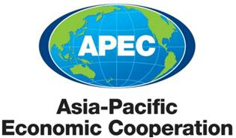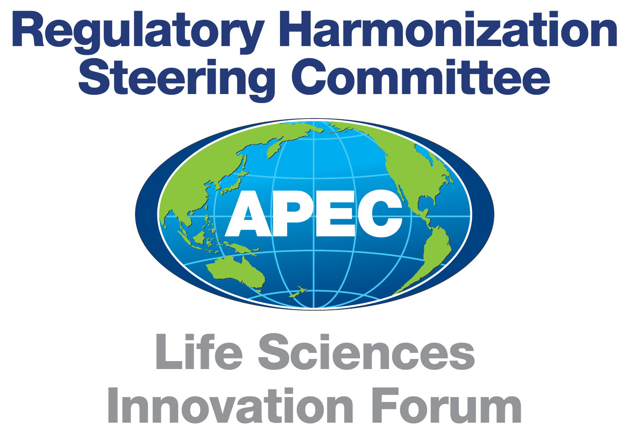
APEC Life Sciences Innovation Forum Regulatory Harmonization Steering Committee

2012/RHSC/XXXXX

Roadmap to Promote Global Medical Product Quality and Supply Chain Integrity

Goal of Topic: Develop and implement global and regional strategies to promote medical product integrity and supply chain security.

1. OVERVIEW (Background and Challenges)

We live in a world that increasingly relies on the global marketplace to produce the medical products we need to keep us well. Many countries around the world import products, rather than rely on their domestic market. For example, in the United States, imports of pharmaceutical products have increased by nearly 13% per year. In the decade ahead, the world economy will be shaped by several distinct forces: the rise of emerging markets, the scarcity of natural resources and the increased flow of capital information and goods across borders. The cumulative effect of these trends means not only phenomenal growth in the global marketplace, but increasing complexity for regulators as supply chains become longer and more complex, while the distinction between foreign and domestic manufacturing and distribution continues to blur.

Goods can come from a multitude of economies, flowing through long, multistep processes to convert globally-sourced starting materials into finished, consumable goods (Figure 1). The shift in global product flows makes it difficult to identify the “source” of a product and its components and to ensure that all participants along the supply chain meet their safety and quality responsibilities. In addition, the growth of the global criminal enterprise has jeopardized the safety and security of the global medical product supply from sophisticated threats such as counterfeits/falsified medical products, fraud, intentional product adulteration, theft, and even terrorism.

Figure 1: A simplified schematic example of global medical product supply chain.

Medical Product Components Supplier or Manufacturer
Finished Product Manufacturer
Finished Product Distributor (Primary and Secondary)
Dispensers (Hospitals and Pharmacies)
Patients
Component Distributor

In short, medical product quality is at risk, and we need global and regional efforts to further ensure supply chain integrity for both drugs (including finished drug products active pharmaceutical ingredients, excipients, and other components of finished drugs) and medical devices, including in vitro diagnostics (components and finished devices). We must move globally from a position of intercepting harmful products to anticipating, preventing, and mitigating the manufacturing and distribution of such goods.

There are several key means to promote and ensure medical product quality and supply chain integrity. First, it is important to have sufficient legal, regulatory, enforcement, and laboratory capacity at the regional, national, and global levels to help ensure integrity in the manufacturing and distribution of components and finished products in the legitimate supply chain. Second, global regulatory convergence and standards development will drive efficiencies in the global marketplace. Third, it is essential to have systems in place to identify authentic product and be able to trace back the components and finished products to the original manufacturer. Fourth, information and communication systems and networks must be in place to share appropriate information among regulators and law enforcement. Fifth, global cooperation and collaboration is essential to leverage resources between member economies and existing medical product quality and supply chain integrity initiatives, regulatory authorities, knowledge, and expertise.

This Roadmap is intended to elicit support from APEC Regulatory Harmonization Steering Committee (RHSC) members to develop and implement a strategic work plan for improving the integrity of the medical product supply chain for components and finished products moving in international commerce throughout APEC. Each initiative developed from this Roadmap is intended to interface with other efforts to improve product quality and supply chain integrity by leveraging related programs (e.g. World Health Organization, Pharmacopeias, APEC Roadmaps, etc) and relationships, including those with countries outside the APEC region.

2. DEVELOPMENT OF A STRATEGIC WORK PLAN
A strategic work plan should be developed by APEC RHSC to identify a path forward toward regulatory convergence of practices necessary to ensure the integrity of marketed medical products. The strategic work plan should address best practices, gap analyses of those practices within APEC economies, suggest mechanisms to help fill those gaps such as training, seminars, symposia, and workshops, recommendations for new guidelines or revisions to existing guidelines, and consideration of other relevant frameworks within APEC, including the APEC/Life Science Innovation Forum (LSIF) Anti-counterfeit Medical Products Action Plan. The strategic work plan should also provide a feedback loop for modification of the plan based upon outcomes assessment and success in achieving increased supply chain security.

It is anticipated that once the subcommittee of RHSC regulators is in place, the strategic work plan will be drafted within 6 months. Timeframe for implementation will be determined upon recommendation by the RHSC.

Step 1: Formation of a Subcommittee

A supply chain subcommittee including RHSC regulators, industry representatives, academics and other appropriate stakeholders from participating APEC economies will be formed. The team will report regularly to the RHSC. This subcommittee will be responsible for overseeing the development and implementation of the strategic work plan for global medical product quality and supply chain integrity. The strategic work plan should take into consideration the information obtained in the gap analysis (discussed below), as well as any other relevant information that is obtained through fact finding and the strategic planning process.

Step 2: Gap Analysis of Required Systems and Practices

A gap analysis should be conducted to identify the current state of supply chain integrity impacting APEC economies and to assess what is needed for national and regional efforts in APEC economies and on the global level with respect to:

- Capacity: Legal, regulatory, enforcement, and laboratory
- Standards/regulatory convergence: Identifying appropriate areas where standards development and regulatory convergence are needed
- Information sharing: Including impediments, technological means and needs Collaboration and cooperation: Identifying global and regional venues for collaboration and cooperation and oversight of implementation of the Roadmap, bringing together regulators, industry, law enforcement, border protection agencies and other important stakeholders.

It is expected that the gap analyses may be completed within 6 months after the adoption of the Roadmap. The gap analysis should identify and evaluate specific regulatory systems needed to ensure the integrity of the entire global supply chain for the entire life cycle of medical products (i.e. starting materials to finished products), determine best practices, and make recommendations for implementing them. Systems to be evaluated in the gap analysis should address, among others:

2.1. Current Good Manufacturing Practices (cGMP) and Quality Management Systems (QMS) Affecting Supply Chain Security

cGMP for drugs cover the conversion of intermediates into active pharmaceutical ingredients (API), and API and other raw materials into finished drugs - all in a controlled and documented manner. Similarly, QMS for medical devices comprise requirements for the manufacturers of finished medical devices, including the control of components, manufacturing materials, in process devices, finished devices, and returned devices in a defined and documented system. cGMP for drugs and QMS for medical devices specifically obligate manufacturers to qualify vendors and suppliers, conduct testing of incoming materials, and establish procedures and records for the holding and distribution of finished goods. These cGMP and QMS requirements are consistent with good distribution practices as they pertain to the life-cycle of a finished product and its components. Additionally, cGMP and QMS requirements for medical products underpin a total life cycle approach from design and development planning through distribution and monitoring and feedback. Understanding how the application of cGMP and QMS may vary across APEC economies is therefore crucial to supply chain integrity.

2.2. Good Distribution Practices (GDP)

With increasing instances of counterfeit, diverted, subpotent, substandard, adulterated, misbranded, or expired medical products moving in international commerce, wide-spread adoption of GDP appear necessary. Consequently, many countries, including some APEC economies, have already developed – or are considering development of – GDP guidelines. In addition, the World Health Organization (WHO) has developed recommended GDP for finished drugs and components moving in international commerce, and acknowledges that the main principles may also apply to medical devices. Despite the individual efforts of regulatory authorities in addressing GDP, global effort would be more effective. Specifically, GDP should address the entire life cycle of medical products, encompassing movement and holding of both components and finished product. Topics may include, among others:

- Personnel and Contractors
- Facilities
- Mode of Transportation
- Receiving and Stock Handling
- Disposal
- Handling of Product Complaints
- Recalls
- Returned Products
- Cold Chain Storage
- Licensing, certification or approval of wholesale distributors and pharmacies

2.3. Good Import and Export Practices (GI/EP)

Perhaps no issue is more impactful to APEC consumers than the import and export rules applicable to the international movement of medical products. For a number of reasons, many countries have stringent import restrictions, but less strict requirements on exports. However, in a multi-lateral, international setting, it is important to approach the flow of medical products as both imports and exports. After all, one APEC economy’s export is another’s import. Understanding the impact of national importing and exporting laws on the integrity of the global supply chain is a key to securing the supply chain. Points to consider may include:

- Educating other government stakeholders (e.g., Customs)
- Labeling requirements for components and finished products
- Applicability of Declarations of Use
- Certification (e.g. Certificates of Pharmaceutical Product)

2.4. Product Identification, Authentication and Traceability

2.4.1.Drugs
Many countries have been evaluating or instituting systems that will provide greater transparency and accountability in their supply chain for medical products. Some systems are based on traceability, some on authentication of an identifier on the medical product package, and others combining elements of both. Almost all of these systems are electronically-based, and could be of tremendous benefit to ensuring the integrity of the medical product supply chain. What is important to consider is the impact of country-specific electronic requirements and standards as compared to a single, international set of requirements that would strive for seamless interoperability of systems as products move in international commerce throughout APEC.

2.4.2. Medical Devices

Many regulators, including FDA, have been working towards the development of a globally harmonized approach to Unique Device Identification (UDI). A UDI System provides a standardized, unambiguous two-part identifier for all medical devices and an associated set of identifying information and other critical elements. Global Harmonization Task Force (GHTF) recently (September 2011) published a UDI guidance to provide a framework for any regulator who is interested in developing their own UDI System. The goal of these efforts is to allow a single UDI to be used anywhere in the world and have the same meaning for various regulatory and supply chain purposes. Though regulators and other stakeholders may have different objectives for developing and implementing a UDI System, the development of a globally harmonized UDI System can provide numerous benefits through shared visibility and traceability.

2.5. Detection Technologies

The use of physical and chemical identifiers to determine the legitimacy of medical products has been in use by manufacturers for many years. Manufacturers have also adopted sophisticated technologies for container-closure and packaging systems. These measures require that regulators consult with manufacturers before determining whether a product is legitimate using valuable response time. Meanwhile, vulnerable patients may be exposed to counterfeit, diverted, or other adulterated products. Consequently, many of the APEC economies have invested heavily in technologies that enhance the surveillance efforts of regulatory authorities by allowing them to make more immediate determinations as to the authenticity of the product.

It is paramount that all APEC economies and their responsible regulatory authorities understand, and have confidence in, these technologies. Accordingly, assessment of detection technologies and their availability and applicability throughout APEC economies will be extremely important in alleviating regulatory concerns among APEC economies. Moreover, education of the public health benefit associated with early detection will enhance the public health outcome of the Roadmap.

2.6. Internet Sales

Internet-based sellers and pharmacies that are selling counterfeit, diverted, subpotent, substandard, adulterated, misbranded, or expired medical products is a growing problem throughout APEC economies. While internet-based sellers and pharmacies can play a role in providing patients with needed access to important medicines or treatment, it is imperative that they be operating with appropriate oversight to ensure they adhere to GDP and other applicable laws. As part of the strategic work plan, the subcommittee could evaluate best practices of internet-based pharmacies and the role they play in the supply chain, as well as the unique risks they may present to patient safety.

For example, the subcommittee could evaluate best practices of internet-based retailers and large auction sites to ensure that medical products requiring prescriptions are not sold to consumers lacking such an order from a licensed health care professional, that physician-administered products not offered for auction, that expired items are not offered for auction under any non-medical category, and that recalled medical products are not bought and sold unless proof of reconditioning or correction is provided.

2.7. Single Point-of-Contact

The strategic work plan should focus on the development and adoption of strategies to mitigate the movement of counterfeit, diverted, subpotent, substandard, adulterated, misbranded, or expired medical products moving in commerce throughout APEC economies. One such strategy might be the implementation of a single point of contact system for sharing information, initiating investigations and creating public awareness. Development of a public awareness tool kit, a guidance document on how to establish and use a single point of contact system, and workshops focused on the development, use and implementation of these documents might be key aspects of the strategic work plan.

Step 3: Development of relevant materials

Relevant materials, including guidelines, best practices, standards, training materials and modules, should be developed for the issues identified in the gap analysis. Appropriate entities operating in APEC economies, such as standards organizations, multi-lateral organizations, or others can be identified to lead such efforts. Specific action plans and timelines can be further refined by the lead for a given issue, and could also include drafting of specific documents or initiation of subprojects which will be directed by the oversight subcommittee.

Although specific timelines have yet to be determined, it is anticipated that some materials in this stage can be completed in as early as six months while others may take as long as five years to complete.

Step 4: Training

A training curriculum will be developed based on the strategic work plan or appropriate entities, such as standards organizations, multi-lateral organizations, or others will be identified to develop or conduct such training. Materials developed in support of the strategic work plan will be used to conduct appropriate workshops and seminars to APEC economies and relevant stakeholders, such as industry, medical product regulatory authorities, health care professionals, and others. To the greatest extent possible, training sessions shall use a train-the-trainer format, in order to promote further training to additional audiences.

Because the strategic work plan should mandate working across APEC organizations on matters that address supply chain security, some training programs could be developed simultaneously with the adoption of the Roadmap and implemented shortly thereafter.

Step 5: Assessments

Assessments (internal, external, and/or self-assessments), which will be determined following the gap analysis, shall be performed to evaluate the effectiveness of the training programs within member economies and determine if any modifications are needed. Training would be updated/revised and conducted with assistance from other APEC economies and/or the RHSC or other entity, as appropriate. Use of case studies based on actual implementation of the topic under consideration and development of key metrics should be considered for each key issue..

The subcommittee will evaluate the implementation and progress of the strategic work plan and will make course adjustments, as needed. Any changes in the strategic work plan will be discussed with the RHSC.

- CONCLUSION

The approach of the strategic work plan should address supply chain issues related to the full life-cycle of the medical product to ensure the highest quality of the product and improve the integrity of the supply chain. The following table outlines the key components discussed above which the APEC RHSC may consider in the development of a strategic work plan intended to promote enhanced supply chain integrity:

KEY ISSUES | Gap Assessment | Development of Materials | Training | Program Assessment
cGMP and QMS
GDP
GI/EP
Product Identification, Authentication and Traceability
Detection Technologies
Internet Sales
Single Point of Contact
(Add Other Agreed Upon Issues)

