ADMINISTRATIVE CIRCULAR

APEC E-Trade and Supply Chain Management Training Course
(Phase II: Financial Supply Chain Management)

Aug. 2008
APEC E-Commerce Business Alliance
1. PURPOSE
1.1 This circular provides administrative, logistical and general information for APEC e-trade and supply chain management training course (Phase II: Financial Supply Chain Management) hold in Sanya, Hainan province, China on 11-12 Nov., 2008.

2. BACKGROUND
- To introduce the new models and management of financial supply chain for SME finance through education among APEC members, especially developing member economies;
- To strengthen cooperation including supply chain and the facilitation of payment, electronic presentation and other financial services so as to enhance bilateral or multi-lateral trade flow among APEC member economies;
- To reinforce the collaboration between policy makers, officials, enterprises and academies to create a better economic environment;

In the long term, such exchanges and cooperation will be expected to be continued and strengthened, with a view to help member economies, especially developing economies better participate in promoting trade facilitation.

3. MEETING DATES AND VENUES
3.1 APEC Training Course on E-Trade and Supply Chain Management (Phase II: Financial Supply Chain Management) will be held in Sanya, Hainan province, China from Tuesday 11 November to Wednesday 12 November, 2008.
3.2 The venue of the training course will be in Sanya Gloria Resort.

4. METHODOLOGY
4.1 Evaluation: Participants are required to complete and return the evaluation form by the end of this program. In the evaluation form, each participant is encouraged to discuss benefits received from the training course.
4.2 Disclosure policy: The lecture materials will be circulated to all attendees and uploaded to the ECBA’s website (www.apec-ecba.org) after the training course.

5. LANGUAGE
5.1 APEC E-Trade and Supply Chain Training Course (Phase II: Financial Supply Chain Management) will be conducted in English.

6. EXPENSES AND ALLOWANCE
Delegates from all APEC member economies are welcome to participate in the training course.
APEC funding for round trip economy class airfare is also being offered for two active-participants from travel-eligible economies. Travel-eligible economies include Chile, People Republic of China, Indonesia, Malaysia, Mexico, Papua New Guinea, Peru, the Philippines, the Russian Federation，Thailand and Viet Nam. Other participants are welcome to attend the training course on a self-funded basis or funded by their own economy.
Lecturers funded by APEC will be provided with round trip economy class airfare and per diem covering accommodation, meals and all other incidental expenses. Detailed agreements for reimbursement shall be stipulated before arrival. Per Diem is paid from the arrival day till the last day of official duty. There will also be an additional payment incorporated under per diem for lecturers. This additional payment element is meant to cover such items as visa fees, travel insurance, bank and currency charges (and other expenses related to reimbursement), and transport to and from airport.
Lecturers and active Participants who are confirmed funded by APEC, must submit their best Airfare Quotation and Detailed Travel Itinerary from a Travel Agent (clearly indicating the airfare, taxes, currency, flight duration of each sectors, travel class, arrival & departure dates & times, etc.) to the APEC Secretariat directly and please indicate ECSG01/2008T (by Email: bec@apec.org or Fax: 65-68 919 690 , Attention: Ms. Belinda Chok (cc: pys@apec.org, xumeng@ec.com.cn and wangmengchao@ec.com.cn )for approval without delay to avoid higher airfares, etc. (before purchase of air tickets) Once approval has been given, the traveler should immediately purchase the ticket at the approved rate. Their airfares should be for the MOST DIRECT (nonstop flights) & Economical route, excluding Travel Insurance, must be a RESTRICTED/discounted ticket). Participants from the same city of residence should have similar airfares.

8. REGISTRATION
8.1 This training course is open to all APEC economies, both public and private sectors and also to international organizations.

8.2 All delegates are to register for this training course using the registration form at Annex A. All completed registration forms are to reach the Secretariat (Attn: Mr. Wang Mengchao at Email: wangmengchao@ec.com.cn or Ms. Xu Meng at xumeng@ec.com.cn or Fax: +86 10 6780 1087) by 10 Oct 2008.

8.3 The Registration Desk will operate at Sanya Gloria Resort, from 10 November to 11 November 2008 as follows:

Monday 10 November 2008 0830 hours - 1800 hours
Tuesday 11 November 2008 0830 hours - 0900 hours

8.4 All delegates are to collect their ID badges at the Registration Desk. They will be required to present their identification when collecting the ID Badges. The ID badges SHOULD BE WORN AT ALL TIMES during the training course and will be required for entry into the training venue.

9. ACCOMMODATION
9.1 Sanya Gloria Resort is the designated hotel for the training course. For more details please check Annex B. Delegates are suggested to arrange their own accommodation bookings with the APEC E-commerce Business Alliance Secretariat by filling out the attached Hotel Reservation Form before Oct.10th, otherwise the rooms and discounted rates are not be ensured. (Annex C)
9.2 As accommodation is tight in Sanya at the time of the training course, rooms will be reserved on a first-come-first-serve basis.
9.3 All costs accrued by delegates in respect of accommodation, telephone, facsimile, laundry, refreshments and meals are the responsibility of the delegates. Delegates should settle their accounts directly with the Hotel before their departure.

10. ARRIVALS AND ENTRY FORMALITIES
10.1 All delegates are required to possess a valid passport or applicable travel document with valid visas or entry permits to enter into China.
10.2 In line with bilateral arrangements, the visa requirement has been waived for delegates who possess diplomatic or official passport from the following economies: Chile, Mexico, Peru, Russia, Thailand, and Viet Nam.

11. TRANSPORTATION
11.1 Sanya Gloria Resort, the venue for the training course, is located in the Yalong Bay, approximately 30-minute shuttle ride either way from the Sanya Phoenix International Airport or from downtown Sanya.
11.2 Taxi will be available at the Sanya airport for transportation to the hotel. The taxi fee is approximately RMB 120 (US$18).
11.3 The International Flight Schedule is at Annex D.

12. DRESS CODE
12.1 The dress code for the training course is smart casual.

13. DELEGATES’ KIT
13.1 All delegates will be provided with a training course kit containing the program, handouts and other materials.

14. BUSINESS SERVICE
14.1 Conference hall and hotel rooms at Sanya Gloria Resort are installed with high speed LAN Interface and multimedia computer, and the Internet access is free of charge.
14.2 Business center, located in the 1st floor of the Sanya Gloria Resort, will provide various services including faxing, printing, etc. for extra costs.

15．CONTACTS
For more information, please feel free to contact:
Mr. Wang Mengchao / Mr. Zhang Dongchen/Ms. XU Meng
APEC e-Commerce Business Alliance Secretariat
Tel: 0086 10 6780 0035/ 0018/1050
Fax: 0086 10 6780 1087
Email: wangmengchao@ec.com.cn
zhangdongchen@ec.com.cn
xumeng@ec.com.cn;

ANNEX A

REGISTRATION FORM

11-12, November 2008

Title | H.E. Dr. Mr. Ms. Others: |  |  |  | Photo
Family Name |  |  |  |  | Photo
Given Name(s) |  |  |  |  | Photo
Name to appear on ID Badge |  |  |  |  | Photo
Gender | Female Male |  |  |  | Photo
Date of Birth | ( dd / mm / yy ) |  |  |  | Photo
Special Requirements | ( dietary / health / physical )
Passport Type | Ordinary Official Diplomatic
Passport No.
Date of Issue | ( dd / mm / yy ) | Place of Issue
Date of Expiry | ( dd / mm / yy ) | Citizenship
Organisation
Department
Position
Business Address
Business Phone
Business Fax
E-mail
Economy

_____________________
Signature

All completed registration forms are to reach the Secretariat (Attn: Mr. Mengchao Wang at Email: wangmengchao@ec.com.cn or Fax: +86 10 67801087) by 10 Oct 2008.

ANNEX B: Hotel Information
- Sanya Gloria Resort（★★★★★）
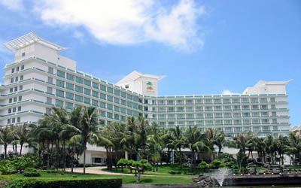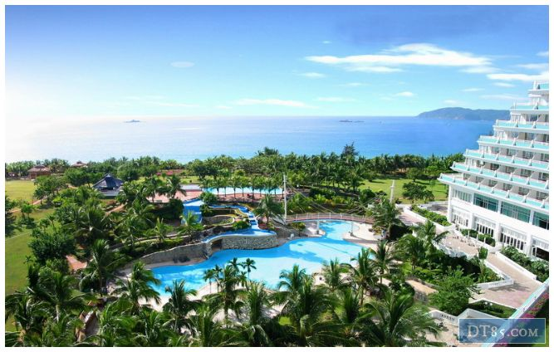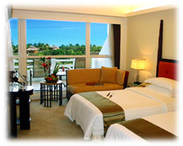

Room Type | Published Rate  (RMB/ Per Night) | Discounted Rate  (RMB/ Per Night)
Superior Ocean View Room | 1,688 | 700
Deluxe Ocean View Room | 1,888 | 750
Grand Ocean View Room (New) | 2,088 | 948
Deluxe Suite | 3,888 | 1,888
Gloria Suite | 5,888 | 2,888
  - All the prices are net rate per room per night include Single/Double buffet breakfast.
  - Please be informed that there is a Prevailing Local Government Tax at RMB 11.00 per night per person.
  - In-house guests can enjoy complimentary Gyms in 2F, Swimming Pool and rooms’ internet for free.
  - Reference exchange rate for USD/RMB, USD1.00=RMB6.5.00; the actual rate, if in USD, should be based on the posted exchange rate on the date of payment;
Add: Sanya Gloria Resort, Yalong Bay National Resort District,
Sanya, Hainan, 572000 P.R. CHINA
Tel: +86 (0) 898 8856 8855 URL: http://www.gloriaresort.com
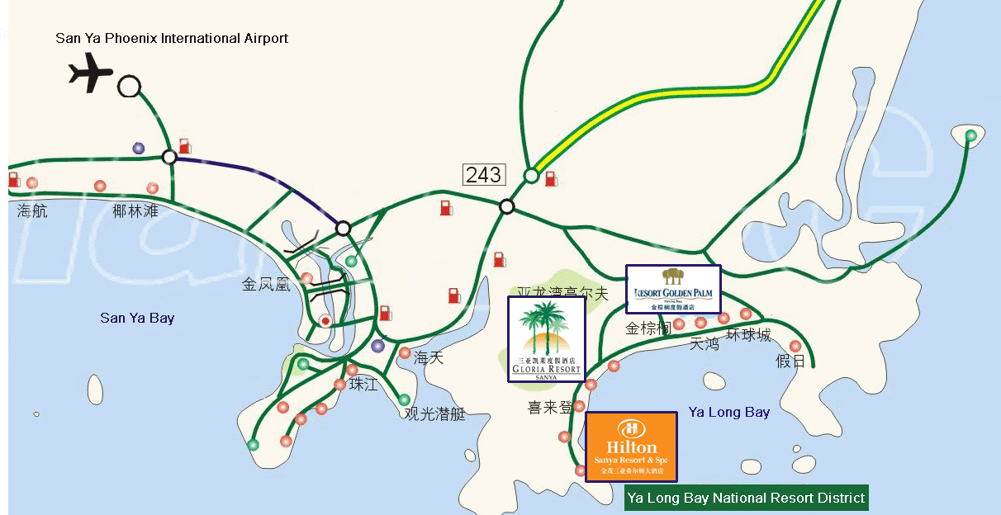

ANNEX C

HOTEL RESERVATION FORM
(Project No. ECSG 01/2008 T)

Participant Details
Title | H.E. Dr. Mr. Ms. Others:
Surname |  | Given Name
Passport No.
A
Organization
Economy
Address
Telephone |  |  | Fax
Email

Reservation Details
Hotel Name
Room Type
Check-in Date/Time
Check-out Date/Time
No. of Nights
Special Requirements

ANNEX D: International Flight Schedule

2008 autumn Sanya Airport airline timetable
IN
1 | KA 650/1 | Hong Kong | 17:05 | Sanya | 18:15 | 2 6
2 | KA 650/1 | Hong Kong | 17:05 | Sanya | 18:15 | 5
3 | KA 650/1 | Hong Kong | 19:15 | Sanya | 19:45 | 1
4 | CZ3029/30 | Hong Kong | 11:20 | Sanya | 12:30 | 1234567
5 | N8 155/6 | Hong Kong | 12:00 | Sanya | 13:10 | 2 4 6
6 | HU 497/8 | Seoul | 20:40 | Sanya | 01:15 | 4 7
7 | MU2040/39 | Seoul | 21:10 | Sanya | 02:00 | 1234567
8 | KE 877/8 | Seoul | 20:30 | Sanya | 00:25 | 3 7
9 | UN535/6 | Moscow | 23:35 | Sanya | 09:35 | 5
10 | UN535/6 | Moscow | 00:35 | Sanya | 10:35 | 3 7
11 | UN535/6 | Moscow | 05:05 | Sanya | 15:05 | 1
OUT
1 | CZ3029/30 | Sanya | 09:00 | Hong Kong | 10:25 | 1234567
2 | KA 650/1 | Sanya | 20:55 | Hong Kong | 22:30 | 1
3 | KA 650/1 | Sanya | 19:30 | Hong Kong | 22:30 | 2 6
4 | KA 650/1 | Sanya | 19:30 | Hong Kong | 21:05 | 5
5 | N8 155/6 | Sanya | 14:05 | Hong Kong | 15:30 | 2 4 6
6 | HU 497/8 | Sanya | 15:40 | Seoul | N/A | 4 7
7 | MU2040/39 | Sanya | 02:50 | Seoul | N/A | 1234567
8 | KE 877/8 | Sanya | 01:35 | Seoul | N/A | 3 7
9 | UN535/6 | Sanya | 11:35 | Moscow | N/A | 5
10 | UN535/6 | Sanya | 12:35 | Moscow | N/A | 3 7
11 | UN535/6 | Sanya | 17:05 | Moscow | N/A | 1

