APEC SCIENCE PRIZE for INNOVATION, RESEARCH and EDUCATION (ASPIRE)

OVERVIEW

The APEC Science Prize for Innovation, Research and Education (“ASPIRE”) is an annual award which recognizes young scientists who have demonstrated a commitment to both excellence in scientific research, as evidenced by scholarly publication, and cooperation with scientists from other APEC member economies, including interdisciplinary collaborations.

The ASPIRE Prize supports APEC’s mission to:
- Strengthen international science and technology networks.
- Enhance economic growth, trade and investment opportunities, through policies, innovative R&D and technologies, and knowledge sharing.
- Improve linkages and efficiency between research and innovation.

ASPIRE 2026 NOMINATION THEME: ADVANCING SCIENTIFIC RESEARCH IN AI AND DATA SCIENCE TO PROMOTE INDUSTRIAL INNOVATION AND ECONOMIC RESILIENCE

For 2026, PPSTI presents the ASPIRE Prize theme: “Advancing Scientific Research in AI and Data Science to Promote Industrial Innovation and Economic Resilience.”

As APEC member economies face complex challenges, cutting-edge technologies such as artificial intelligence are playing a pivotal role in driving regional progress and evolution in the Asia-Pacific region. The theme of APEC Science Prize for Innovation, Research and Education (ASPIRE) 2026, "Advancing Scientific Research in AI and Data Science to Promote Industrial Innovation and Economic Resilience," focuses on the basic scientific research and digital platforms that support regional prosperity and stability. We invite nominations that delve into the frontiers of AI and other related emerging technologies that provide scalable solutions for civil society, companies, and public institutions. Examples include AI algorithms for analyzing astronomy data; cutting edge research in computer science and data science; innovations integrating AI in medicine, and AI-driven infrastructures for materials science, biotechnology and energy.

This theme highlights the role of trusted AI for both basic scientific research, and applied research to promote the development of secure digital platforms for accelerating scientific discovery and industrial innovation, rooted in values such as reciprocity, transparency, and accountability. By building digital platforms in collaborative, secure innovation ecosystems, we aim to accelerate breakthroughs in material science, energy, and biotechnology, while promoting appropriate protections for intellectual property and national security. These platforms act as "force multipliers," enabling young scientists across APEC economies to collaborate on voluntary, mutually agreed terms to provide solutions to grand challenges.

By focusing on these fundamentals, we recognize the important potential of original innovation in supporting economic prosperity and human flourishing. Nominees should demonstrate excellence in scientific research and show commitment to cross-border cooperation among APEC economies. The 2026 ASPIRE Prize will champion those young scientists who have made remarkable achievements in emerging technologies, particularly in AI and interrelated frontier fields that fuel industrial innovation and bolster economic resilience, fostering an open, dynamic, resilient, and peaceful Asia-Pacific community by 2040.

ELIGIBILITY

Any citizen of an APEC member economy is eligible to be nominated for the ASPIRE Prize. He or she must be under 40 years old as of 31 December 2026.

SELECTION PROCESS

Each member economy, through its representative on the APEC Policy Partnership for Science, Technology and Innovation (PPSTI), is invited to nominate one young scientist under the age of 40 to be considered for the 2026 ASPIRE Prize.

Once nominations are received, PPSTI members rank the nominees through a selection ballot to determine the winner. PPSTI members are asked to judge the nominees based on how well they have demonstrated:
- Excellence in scientific research, as evidenced through scholarly publication;
- Commitment to cooperation with scientists from other APEC member economies; and
- Contribution to the theme of “Advancing Scientific Research in AI and Data Science to Promote Industrial Innovation and Economic Resilience.”

ASPIRE PRIZE SPONSORS

The National Center for APEC Foundation, based in the United States, is generously sponsoring the 2026 ASPIRE Prize with an award of $25,000 USD in prize funding.

PREVIOUS ASPIRE PRIZE WINNER

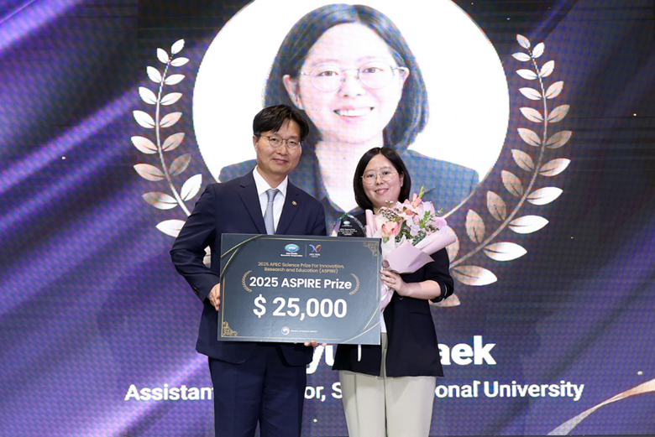 | 2025: AI-Powered Breakthrough in Protein Design  Dr. Minkyung Baek, a computational biologist from the Republic of Korea, was awarded the 2025 ASPIRE Prize at a ceremony held in Incheon, Republic of Korea. Dr. Baek is an Assistant Professor at Seoul National University. Her research is focused on AI-powered protein structure prediction and design, with the goal of accelerating the development of medicines and sustainable materials. She developed an AI tool that enables scientists to predict the three-dimensional shapes of proteins, facilitating faster vaccine development, novel drug discovery, and the design of proteins not found in nature. Her work exemplifies the convergence of artificial intelligence and biotechnology in addressing real-world health and social challenges across the Asia-Pacific region.
 | 2024: PPSTI did not conduct the ASPIRE PRIZE
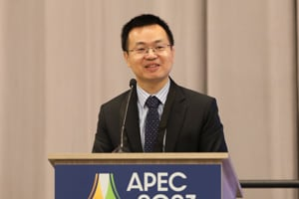 | 2023: Science and Technology for a Resilient Environment  Dr. Zheng Liu, a professor at Nanyang Technological University in Singapore, was awarded the 2023 ASPIRE Prize for his groundbreaking work on two-dimensional (2D) materials. His work has been focused on enhancing semiconducting electrocatalysts and photocatalysts for sustainable energy, electronic device development and fabrication, and integrated Al. His research and its applications have the potential to reduce the risk of energy over-consumption. Dr. Liu’s innovations contribute to sustainability while promoting inclusive scientific collaboration across the APEC region.
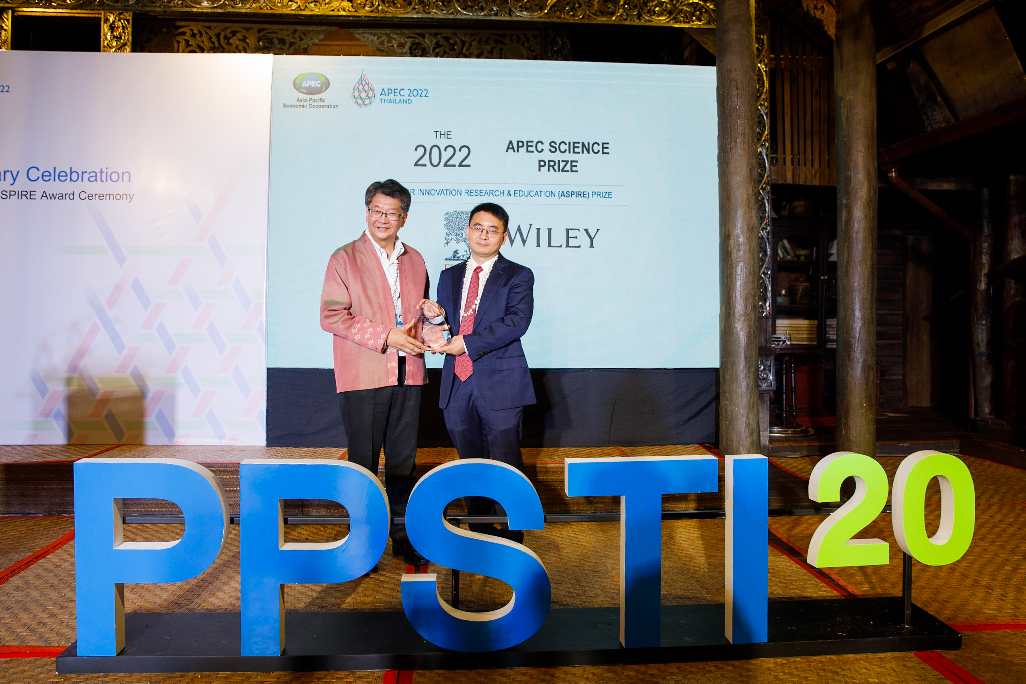 | 2022: Transformation to a Bio-Circular-Green Economy  Dr Jingzheng Ren, an industrial and systems engineer from Hong King, China, was awarded the 2022 ASPIRE Prize at an in-person ceremony in Chiang Mai, Thailand. Dr. Ren is an Assistant Professor at the Hong Kong Polytechnic University. His research is focused on decision-making for economic, industrial, and social systems. He has developed new methods to promote harmonious development of the economy, environment, and society. He has collaborated with scientists in 12 APEC economies and has been published in over 183 scientific journals.
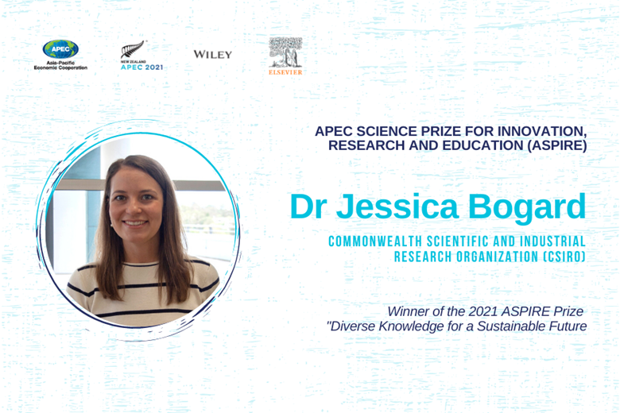 | 2021: Diverse Knowledge for a Sustainable Future  Dr Jessica Bogard, a dietitian and public health nutritionist from Australia, was awarded the 2021 ASPIRE Prize, for her research focusing on boosting the potential of underutilized local and indigenous food to reduce malnutrition, particularly among pregnant women and young children. Dr. Bogard pioneered the development of a database of nutritional quality of more than 50 species of fish and aquatic food and found that certain indigenous species of fish are rich sources of a multitude of micronutrients, but their availability is declining. She is a research scientist at the Commonwealth Scientific and Industrial Research Organisation (CSIRO) Australia.
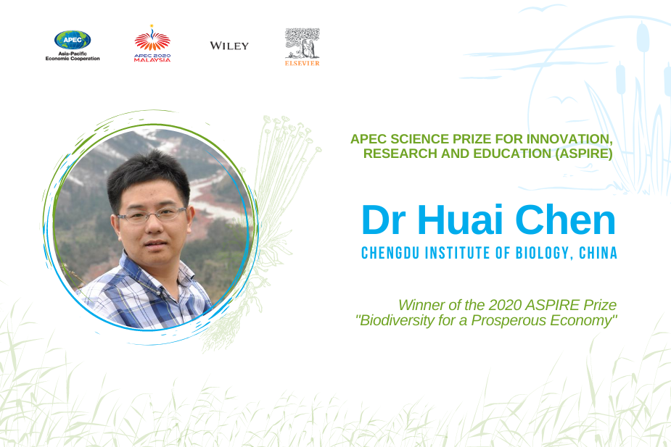 | 2020: Biodiversity for a Prosperous Economy  Dr. Huai Chen was awarded the 2020 ASPIRE Prize at an online ceremony by Dr. Siti Hamisah Tapsir, Secretary General, Ministry of Science, Technology and Innovation (MOSTI) Malaysia Dr. Chen is a professor at Chengdu Institute of Biology, Chinese Academy of Sciences. His research is focused on wetland biodiversity and nature’s contribution to people. Dr. Chen’s findings lead to a better understanding of these wetlands including protecting, developing new generation models for methane emissions and enhancing assessment of carbon storage and ecological value.
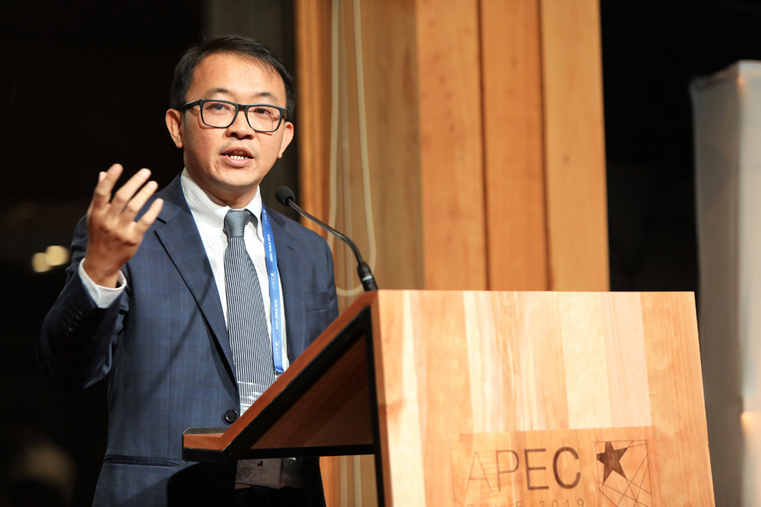 | 2019: Natural Laboratories  Dr. Yun Hau NG was awarded the 2019 ASPIRE Prize in Puerto Varas, Chile by Dr. Nicole Ehrenfeld, Director, Scientific Initiative Millennium, Ministry of Economy, Chile. Dr. Ng is an associate professor at the School of Energy and Environment, City University of Hong Kong, China. His research is focused on the development of highly efficient photocatalytic systems to mimic natural photosynthesis to produce clean hydrogen from water. In short, he uses sunlight to split water into clean hydrogen.
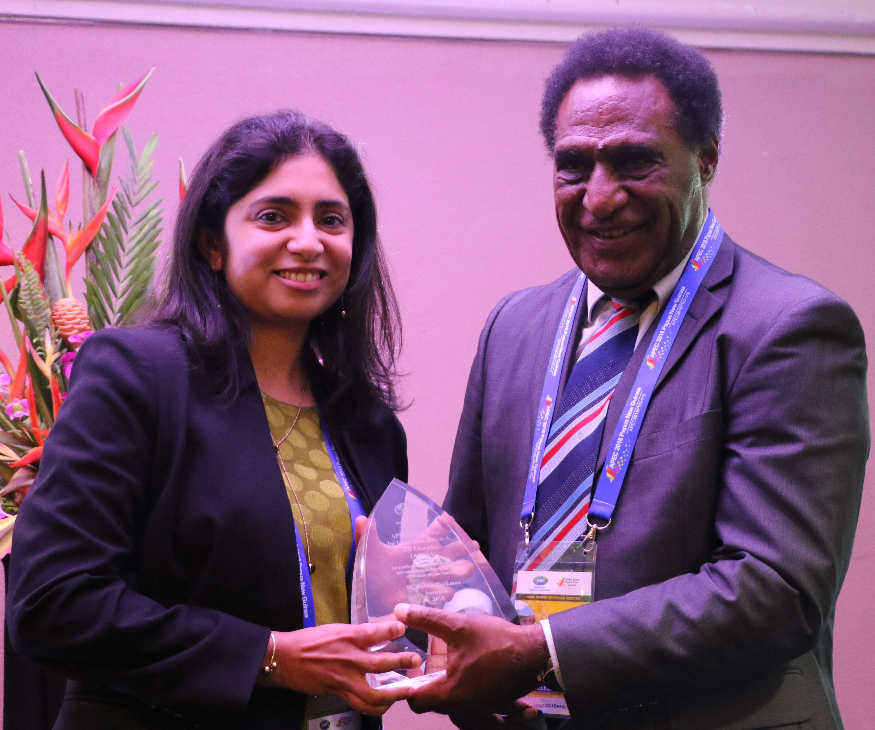 | 2018: Smart Technolgies for Healthy Societies  Dr. Madhu Bhaskaran of Australia was awarded the 2018 ASPIRE Prize in Port Moresby by Hon. Pila Niningi, Minister for Higher Education, Research, Science and Technology of Papau New Guinea. Dr. Bhaskaran is a professor at RMIT University, Melbourne, Australia where her work transforms the way we imagine, use and interact with electronic devices and sensors. She has developed ways to combine functional oxide materials processed at high temperatures with elastic and plastic materials. Her work has led to the development of wearable elastic electronics and sensors, including gas and UV sensors and flat optical devices—all of which are stretchable, optically transparent and as thin as a nicotine patch.
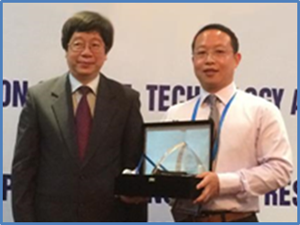 | 2017: New Material Technologies  Dr. Yanwu Zhu of China was awarded the 2017 ASPIRE Prize in Ha Noi by Deputy Minister of Science and Technology of Viet Nam, Tran Quoc Khanh. Dr. Zhu is a Professor at the University of Science and Technology of China where he researches the fields of nanomaterials and specifically new carbon materials. His publications have been widely cited and his research with other APEC scientists has been applied in large-scale production of graphene materials.
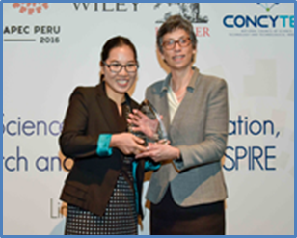 | 2016: Technologies for Food Security  Dr. Hua Kuang of China was awarded the 2016 ASPIRE Prize in Lima by Dr. Gisella Orjeda, President of the Peruvian National Council for Science, Technology and Technological Innovative (CONCYTEC). Dr. Kuang is a Professor at Jiangnan University’s School of Food Science and Technology in Wuxi, China, where she works with researchers in other APEC economies to develop low-cost biosensors that detect food sanitation hazards. Her patented technologies have been used to improve food safety for millions in China and elsewhere.
 | 2015: Disaster Risk Reduction: Understanding the Role of Climate Change and Variability  Dr. Jong-Seong Kug of Korea was awarded the 2015 ASPIRE Prize in Manila by Secretary Mario Montejo of the Philippine Department of Science and Technology. Dr. Kug is an Associate Professor at Pohang University of Science and Technology’s School of Environmental Science and Engineering in Korea, and his El Niño prediction model has helped the Korea Meteorological Administration better understand tropical climate dynamics, and forecast and track extreme weather—an area that addressed Philippines’ theme of “Disaster Risk Reduction: Understanding the Role of Climate Change and Variability.”
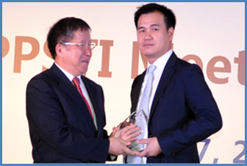 | 2014: Intelligent Transportation  Dr. Agachai Sumalee, a Thai professor at the Hong Kong Polytechnic University, was awarded the 2014 ASPIRE Prize by Cai Jianlin, China’s Vice Minister of Science and Technology. China selected the theme of “Intelligent Transportaion”to reflect China’s interest in facilitating green and sustainable growth, environmental protection and low-carbon economies. Dr. Sumalee designed a model in collaboration with researchers from across the APEC region that allows highway managers to predict traffic conditions and prevent congestion. This led to ground breaking road traffic management system that slashed commuting times in the greater Bangkok area.
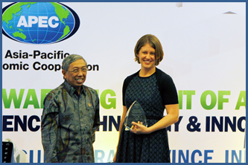 | 2013: Sustainable Ocean Development  In 2013 the ASPIRE Prize was awarded by Gusti M. Hatta, Indonesia’s Minister of Research and Technology, to Dr. Carissa Klein of Australia. Dr. Klein’s research with the University of Queensland uniquely addressed the 2013 ASPIRE nominating theme of “sustainable ocean development” by striking a balance between biodiversity conservation and socioeconomic viability. Her work has helped two APEC member economies—Malaysia and the United States—sustainably zone the ocean for fishing and conservation.
 | 2012: Health Innovation  Dr. Rossa Wai Kwun Chiu of Hong Kong, China was awarded the 2012 ASPIRE Prize. Russia selected “health innovation” as its ASPIRE nominating theme, building on it desire that APEC actively foster cooperation among economies in major innovation areas, such as human health, to support healthy lifestyles, productivity and economic growth. Dr. Chiu’s groundbreaking research and innovations in chemical pathology has brought non-invasive prenatal diagnosis of fetal genetic diseases into routine clinical use around the world.
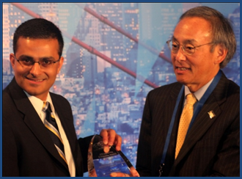 | 2011: Green Growth  In 2011 the ASPIRE Prize was awarded by Nobel Laureate and U.S. Secretary of Energy Steven Chu to Dr. Ali Javey of the United States. The United States selected “green growth” as its ASPIRE nominating theme, building on its desire that APEC actively promote environmentally sustainable economic growth and development, and help our economies successfully transition to a clean energy future. Dr. Javey’s innovative work with nanomaterials has made great strides in developing a new generation of solar energy technology and reducing energy consumption in “green electronics.”

Enclosures
ASPIRE 2026 Selection Process & Key Dates 9
ASPIRE 2026 Letter to Local Educational and Research Institutions 12
ASPIRE 2026 Nomination Form 13
ASPIRE 2026 Example Applicant Review Sheet 17
ASPIRE 2026 Member Economy Nomination Cover Letter 19

ASPIRE 2026 Selection Process & Key Dates

ACTIONS | SUPPORTING DOCUMENTS IN PACKET | DATE
EACH APEC ECONOMY SEEKS LOCAL NOMINATIONS  Each APEC member economy, through its PPSTI representative, is requested to seek nominations from within his or her economy in order to determine one nominee per member economy. It is recommended that nominations be actively solicited from top educational and research institutions within the economy.  Example local nomination process:  Step 1—Seek Local Nominations: PPSTI representative to send Nomination Form and accompanying Letter to Local Educational and Research Institutions requesting them to publicize/promote the ASPIRE Prize through a call-for-nominations. Local competitions held by prominent institutions to publicize/promote the ASPIRE prize are highly encouraged.  Step 2—Establish Peer Review Panel to Select Economy’s One Nominee: PPSTI representative to receive completed local nomination applications (completed Nomination Forms) and establish a panel to judge the applications and select one nominee. | Step 1 documents  - Nomination Form  - Letter to Local Educational and Research Institutions  Step 2 documents  - Example Applicant Review Sheet | Step 1 Suggested Timing: Late March  Step 2 Suggested Deadline: Mid-May
EACH APEC ECONOMY SUBMITS ONE NOMINEE  Each APEC member economy submits one nominee to represent his or her economy for the 2026 ASPIRE Prize. Submissions are made via e-mail before June 9 17:30 (Singapore time) to PPSTI Program Director, rh23@apec.org, copy ppsti@apec.org; swt@apec.org. The submission should include 1) The nominee’s Nomination Form; 2) the Member Economy Nomination Cover Letter | - Nomination Form  - Member Economy Nomination Cover Letter | Deadline:  9 June

ACTION | DATE
PPSTI PROGRAM DIRECTOR SENDS PROFILES TO PPSTI REPRESENTATIVES  The PPSTI Program Director will collate the nominations received from each member economy and distribute them to PPSTI members for ranking.  Sponsors shall provide Scopus profiles, as available, for each economies' nominee to assist PPSTI members in their ranking. | By: 19 June
APEC ECONOMIES RANK NOMINEES AND SUBMIT SELECTION BALLOT  Each APEC member economy, through its PPSTI representative, is requested to rank the nominees and submit a selection ballot to the PPSTI Program Director by 13 July 17:30 (Singapore time). | Deadline:  13 July
PPSTI PROGRAM DIRECTOR COMPILES SELECTION BALLOT  The PPSTI Program Director shall compile and forward the results and the completed selection ballots to the PPSTI Chair to confirm the winner.  *In case of a tie, the PPSTI Chair will determine the winner. | By: 17 July
NOTIFY PPSTI MEMBERS OF 2026 ASPIRE WINNER  The PPSTI Chair and the ASPIRE sponsors jointly notify PPSTI members of the 2026 ASPIRE winner. | By: 19 July
NOTIFY 2026 ASPIRE WINNER  The PPSTI Chair and the ASPIRE sponsors jointly notify the 2026 ASPIRE winner. | By: 26 July
AWARD CEREMONY  The winner of the 2026 ASPIRE Prize is recognized at an award ceremony during the PPSTI meeting hosted by the China. | August TBD

2026 APEC Science Prize for
Innovation, Research and Education

LOCAL NOMINATION FORM FOR [INSERT ECONOMY]

DUE DATE: [INSERT YOUR ECONOMY'S NOMINATION DEADLINE -- SUGGESTED MID MAY DEADLINE]

ASPIRE 2026 Letter to Local Educational and Research Institutions

Dear [NAME]:

It is with great enthusiasm that we announce that nominations are being sought to represent [INSERT ECONOMY] for the 2026 APEC Science Prize for Innovation, Research and Education (ASPIRE Prize). Sponsored by the National Center for APEC Foundation, based in the United States, the ASPIRE Prize is an annual award that recognizes young scientists who have demonstrated a commitment to both excellence in scientific research and cooperation with scientists from other APEC member economies.

[INSERT ECONOMY] may nominate one young scientist from [INSERT ECONOMY] under the age of 40 to be considered for the 2026 ASPIRE Prize. These finalists will then be considered by the full APEC Policy Partnership for Science, Technology, and Innovation (PPSTI) for selection as the 2026 ASPIRE Prize winner, with prize money in the amount of $25,000 USD. We encourage your institution to use the enclosed “NOMINATION FORM” to send us distinguished young scientists for consideration by [DATE - SUGGEST MID-MAY DEADLINE].

For 2026, PPSTI presents the ASPIRE Prize theme: “Advancing Scientific Research in AI and Data Science to Promote Industrial Innovation and Economic Resilience.”

Nominees should demonstrate a commitment to excellence in scientific research and cooperation with scientists from other APEC member economies, including interdisciplinary collaborations, in subjects such as: biology, chemistry, environmental science, physics, mathematics, economics, social sciences and other relevant fields.

"The ASPIRE prize represents not only excellence in science and technology, but also our collective aspiration to address global challenges through collaboration and forward-looking leadership in the Asia Pacific community.” – PPSTI Chair Dr. Hwanil Park

We thank you for your institution’s contributions to the APEC region’s scientific community and look forward to reviewing your nominees.

Best regards,

 |  |  | 
 | Dr. Hwanil Park  PPSTI Chair  Science and Technology Policy Institute (STEPI), Korea |  | Ms. Monica Hardy Whaley  President  NCAPEC Foundation  ASPIRE Prize Sponsor

ASPIRE 2026 Nomination Form

INSTRUCTIONS: Thank you for your interest in being selected to represent [INSERT YOUR APEC ECONOMY] for the 2026 ASPIRE Prize. Please send all required documents below and submit to: [INSERT CONTACT NAME AND E-MAIL FOR YOUR ECONOMY’S PPSTI DELEGATE]

REQUIRED DOCUMENTS:
- Nomination form;
- Nominee’s Curriculum Vitae;
- One letter of recommendation for consideration;
- A photo of nominee (image must be larger than 250*300 pixels)

THE DEADLINE IS: [INSERT DATE – SUGGESTED MID MAY DEADLINE. MUST ALLOW YOUR ECONOMY ENOUGH TIME TO MAKE A DECISION ON YOUR ONE NOMINEE AND SEND IT TO to PPSTI Program Director rh23@apec.org and copy ppsti@apec.org; swt@apec.org BY June 9]

SECTION 1 OF 5 - Nomination Statement (up to 300 words): Please describe how the nominee has demonstrated excellence in scientific research in the field of “Advancing Scientific Research in AI and Data Science to Promote Industrial Innovation and Economic Resilience” and cooperation with scientists from other APEC member economies. Please also include 1-3 bullet points that could be published on social media summarizing the nominee’s research.
SECTION 2 OF 5 - Nominee Information
Member Economy:
Last Name: | First Name:
Date of Birth (day/month/year):
Address:
Telephone: | Email:
Title:
Institution/Affiliation:
Field of Research:
SECTION 3 OF 5 - List of Peer Reviewed Scholarly Publications: Please list the nominee’s peer reviewed publications (publication titles should be translated into English). The nominee’s record of scholarly publication will be evaluated on its merits, and nominees are encouraged to include publications regardless of the publisher. Please continue onto separate page if necessary.
Please denote which scholarly publications include co-authors from APEC member economies, for example:
1. A.S. Barnard, H. Konishi, H. Xu, ‘Morphology mapping of platinum catalysts over the entire nanoscale’, Catal. Sci. & Tech. (2011) accepted [APEC Authors]
2. H. Guo, A.S. Barnard, ‘Computational challenges in accurate modeling of iron oxides and oxyhydroxides, and the prediction of environmentally sensitive phase transformations’, Phys. Rev. B, 83 (2011) 094112
3. L.Y. Chang, E. Osawa, A.S. Barnard, ‘Confirmation of the electrostatic self-assembly of nanodiamonds’, Nanoscale, 3 (2011) 958 [APEC Authors]

SECTION 4 OF 5 - Other Awards/Achievements/Contributions to market-led innovations: Please list below in English; please continue onto separate page if necessary.
Please denote which, if applicable, have a connection to other APEC member economies.

SECTION 5 OF 5 – Local Nominator Information (If Nomination Form is submitted by the nominee himself or herself, do not fill out this section)
Last Name: | First Name:
Telephone: | Email:
Relation to Nominee (if any):
Title:
Institution/Affiliation:
Nominator Signature (typed):

Remember to include the following attachments along with this Nomination Form:

- Nominee’s Curriculum Vitae
- One letter of recommendation
- Photo of nominee (image must be larger than 250*300 pixels):

2026 APEC Science Prize for
Innovation, Research and Education

EXAMPLE APPLICANT REVIEW SHEET

Note: After receiving local nominations within the APEC economy, it is suggested that the PPSTI representative establish a panel to judge the applications and select one nominee.

ASPIRE 2026 Example Applicant Review Sheet

Candidate Name: | TOTAL SCORE:
Nominating Institution: | TOTAL SCORE:
Candidate meets eligibility requirements:
□ Yes, candidate will be under the age of 40 as of December 31, 2026.
□ Yes, candidate is a citizen of an APEC economy.
Criteria 1: Excellence in scientific research as evidenced by scholarly publication (10 being the highest and 1 being the lowest)
1 | 2 | 3 | 4 | 5 | 6 | 7 | 8 | 9 | 10

Comments:

Criteria 2: Cooperation with scientists from other APEC member economies
1 | 2 | 3 | 4 | 5 | 6 | 7 | 8 | 9 | 10

Comments:

Criteria 3: Contribution to this year’s theme of “Advancing Scientific Research in AI and Data Science to Promote Industrial Innovation and Economic Resilience”
1 | 2 | 3 | 4 | 5 | 6 | 7 | 8 | 9 | 10

Comments:

2026 APEC Science Prize for
Innovation, Research and Education

MEMBER ECONOMY NOMINATION COVER LETTER

APEC ECONOMY: [INSERT ECONOMY]
DUE DATE: June 9, 2026

FOR COMPLETION BY APEC ECONOMY PPSTI DELEGATE ONLY

Note: Each APEC member economy should select their one nominee for the 2026 ASPIRE Prize – as well as submit their nomination to the Program Director and the Program Executive of the APEC PPSTI

ASPIRE 2026 Member Economy Nomination Cover Letter

Member Economy
Name of Economy Nominee
Last Name: | First Name:
Economy Nominator Information (PPSTI Delegate)
Last Name: | First Name:
Telephone: | Email:
Relation to Nominee (if any):
Title:
Institution/Affiliation:
Nominator Signature (typed):

Remember to append all nomination documents with this cover letter:

- Nomination Form
- Nominee’s Curriculum Vitae
- One letter of recommendation
- Photo of nominee (image must be larger than 250*300 pixels):

Please submit all nomination documents along with this nomination cover letter to PPSTI Program Director rh23@apec.org and copy ppsti@apec.org; swt@apec.org before 9 June 2026 17:30 (Singapore time).

