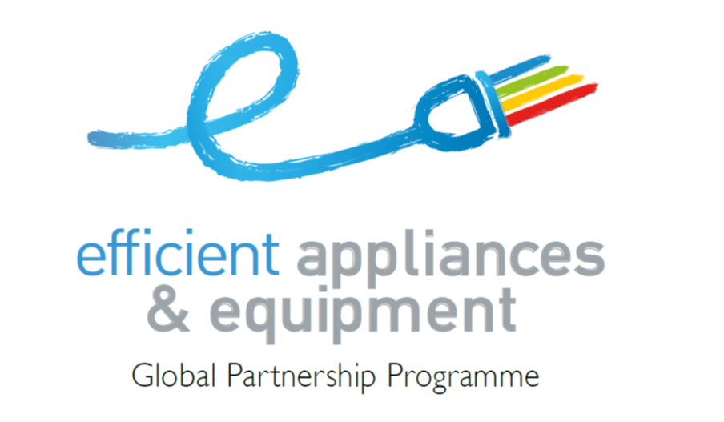

ENERGY EFFICIENCY

accelerate the transition to efficient appliances and equipment



Global Partnership Programme



United Nations Environment Programme

Division of Technology, Industry and Economics

75441 Paris Cedex 09 · France

In my capacity as representative of the Government of _____________________ [name of country] I request the accession of ________________________ [name of country] as a partner of the Global Partnership for Efficient Appliances and Equipment under the accelerator of the Sustainable Energy for All Initiative of the United Nations,   
to promote the transition to efficient products and equipment.

As a member of this partnership my country receives technical support and information in obtaining funding for actions to promote the transition to efficient appliances and equipment.

The following officer is designated as the focal point of the Partnership for Efficient Appliances and Equipment in   
my country.

Name: _____________________________________________________________

Title: _____________________________________________________________

Address: _____________________________________________________________

E-mail: _____________________________________________________________

Name & Signature [Minister or Vice Minister] and Ministry Official Seal Date