|  |  |  |  |  |  |
| --- | --- | --- | --- | --- | --- |
| Registration Form | | | | | |
|  | | | | | |
| **1. Personal Information** | | | | | |
| □ Mr. □ Ms. □ Dr. | | | | | |
| **First name :** | | **Last name :** | | | |
| **Position :** | | **Department :** | | | |
| **Company/Organization :** | | | | | |
| **Address :** | | | | | |
| **Economy :** | | **Postcode :** | | | |
| **Tel:** | | **Fax:** | | | |
| **E-mail:**  *(**※ Further information and confirmation details will be sent via email so please ensure that your email address is clearly written)* | | | | | |
| **Please indicate ‘■’ if this applies to you *(If you need invitation letter, please fill annex1 )***  □ I need an official invitation letter for entry visa application  □ I need an organization’s invitation letter for entry visa application  □ I need other letter support: note: | | | | | |
| **Please select one:**  □ I am attending as an APEC economy representative  □ I am attending as an Observer | | | | | |
| **Special Dietary Needs**  □ Vegetarian □ Islamic □ Other ( ) | | | | | |
| **2. Confirmation of Attendance** | | | | | |
| ***(※ Please state your participation below)*** | | | | ***Yes*** | ***No*** |
| 11 November, 2013 | 42nd APEC EGEE&C meeting | | |  |  |
| 12 November, 2013 | 42nd APEC EGEE&C meeting (Morning) | | |  |  |
| EGEE&C joint meeting with EGEDA (afternoon) | | |  |  |
| 13 November, 2013 | Workshop – Energy Efficient Distribution Transformers | | |  |  |
| 14 November, 2013 | Workshop – Efficient Air Conditioners (1/2 day) | | |  |  |
| 15 November, 2013 | Site Visit (TBD) | | |  |  |
| **3. Flight Information** | | | | | |
| **Arrival** | | | **Departure** | | |
| Date & Time: (dd)__/April, (hh)__:(mm)____  *(※ Please indicate arrival times to local Beijing time)* | | | Date & Time: (dd)___/ April , (hh)__:(mm)____  *(※ Please indicate departure times to local Beijing time)* | | |
| Flight No. | | | Flight No. | | |

|  |  |  |  |
| --- | --- | --- | --- |
| **Hotel Reservation (during 10-16 November 2013)** | | | |
| **The Imperial Queen’s Park Hotel, Bangkok** *(Official Hotel)*  Address: 199 Sukhumvit 22, Bangkok 10110, Thailand.  Tel: +66-2-261-9000 Fax: +66-2-261-9496 Website: www.imperialhotels.com | | | |
| **Total No. of Nights:** | | | |
| **Check-In Date: (dd)_____/November 2013** | | **Check-Out Date: (dd)_____/November 2013** | |
| **Room Rate for the Imperial Queen’s Park** | **Room Type** | **Rate per Night**  **(Single/Double)** | **Your Choice(✓)** |
| **Deluxe** | **USD 117/USD 130** |  |
| **Premier** | **USD 130/USD 144** |  |
| **Special Request:** | *(※ cannot be guaranteed before your check-in)* | | |
| **Sofitel So Bangkok Hotel**  Address: 2 North Sathorn Rd, Bangrak, Bangkok 10500, Thailand.  Tel: +66-2-624-0000 Fax: +66-2-624-0111 Website: www.sofitel.com | | | |
| **Total No. of Nights :** | | | |
| **Check-In Date: (dd)_____/November 2013** | | **Check-Out Date: (dd)_____/November 2013** | |
| **Room Rate for Sofitel So Bangkok** | **Room Type** | **Rate per Night**  **(Single/Double)** | **Your Choice(✓)** |
| **So Cosy (Skyline View: 38 m2)** | **USD 195/USD 210** |  |
| **So Comfy (Park View: 38 m2)** | **USD 223/USD 238** |  |
| **So Studio (Park View: 65 m2)** | **USD 304/USD 304** |  |
| **Special Request:** | *(※ cannot be guaranteed before your check-in)* | | |
| **Method of**  **Payment** | **□ The Imperial Queen’s Park Hotel □ Sofitel So Bangkok Hotel** | | |
| □ VISA □ MASTER □ AMEX (four digit serial no. required: ______ ) | | |
| Card No.: | | |
| Expiry date (mm/yy): | | |
| Cardholder’s Name on the Card (as printed): | | |
| ***※ Note:***  *1. To get to the official hotel from Suvarnabhumi International Airport (BKK), you can take the Airport Rail Link to Phaya Thai Station then take BTS Sky Train to Phrom Phong Station. The Imperial Queen's Park hotel is situated, just three minutes away from the the station.*  *2. Room rate includes breakfast, tax, and service charge.*  *3. Delegates will be responsible for settling their own account with the hotel on departure. Above rates cover costs for rooms, breakfast, and service charge only. All other expenses will incur as additional charges.*  *4. Reservations for accommodation after* ***15th October 2013*** *may not be guaranteed. If you cancel your accommodation reservation* ***AFTER 16th October 2013***, *cancellation fees are applied.*  *5. Once your room has been reserved, a confirmation letter will be sent out. Please refer to the confirmation letter for detailed regarding cancellation policy.*  *6 .The standard currency rate used is USD.* ***USD 1 = THB 32.00 (as of 12 September 2013)*** | | | |
| * + ***Please return completed form via fax or e-mail by 15thOctober 2013 to Selected Hotel Fax Number. For inquiries, please contact:*** **Department of Alternative Energy Development and Efficiency/ Ms. Duangporn Inpradit**  Tel: +66-89-789-1929 Fax: +66-2-223-1149 E-mail: doungporn.in@gmail.com | | | |

 **APEC EGEE&C Meeting & Workshop**

**11- 15 November 2013, Queen Sirikit National Convention Center, Bangkok, Thailand**

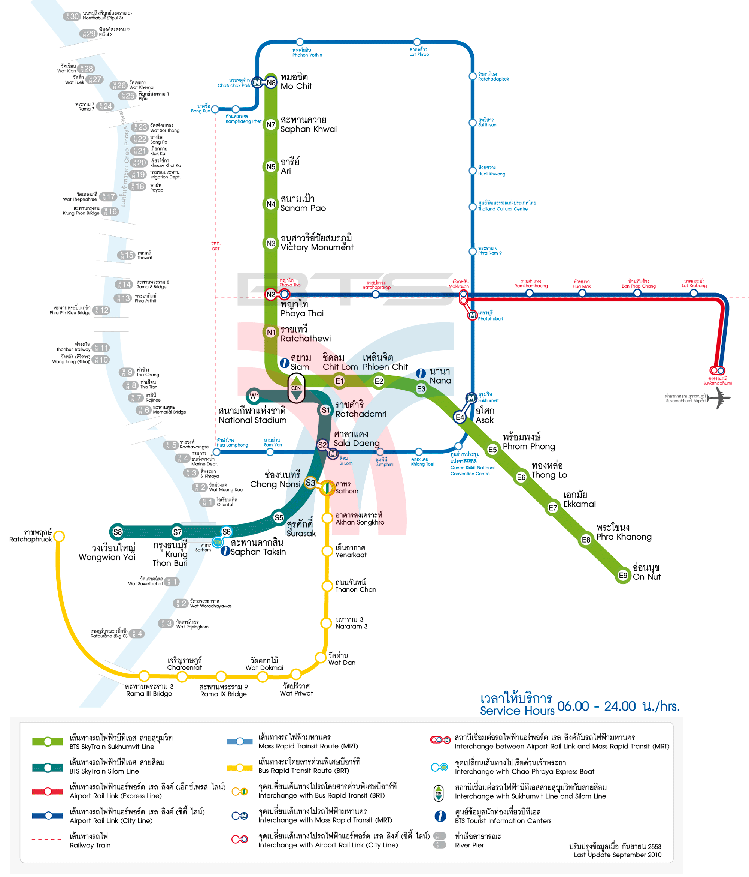

Annex 1

 **APEC EGEE&C Meeting & Workshop**

**11- 15 November 2013, Queen Sirikit National Convention Center, Bangkok, Thailand**

|  |  |
| --- | --- |
| **Information for Invitation Letter** | |
| Full Name on passport |  |
| Passport No. |  |
| Gender |  |
| Nationality |  |
| Date of Birth(DD/MM/YYYY) |  |
| Passport valid period | From: to: |
| **Company/Organization** |  |
| **Position** |  |
| **Address** |  |
| **Invitation period** | **From:** April th,2013 **to:** April th,2013 |
| **Note** |  |