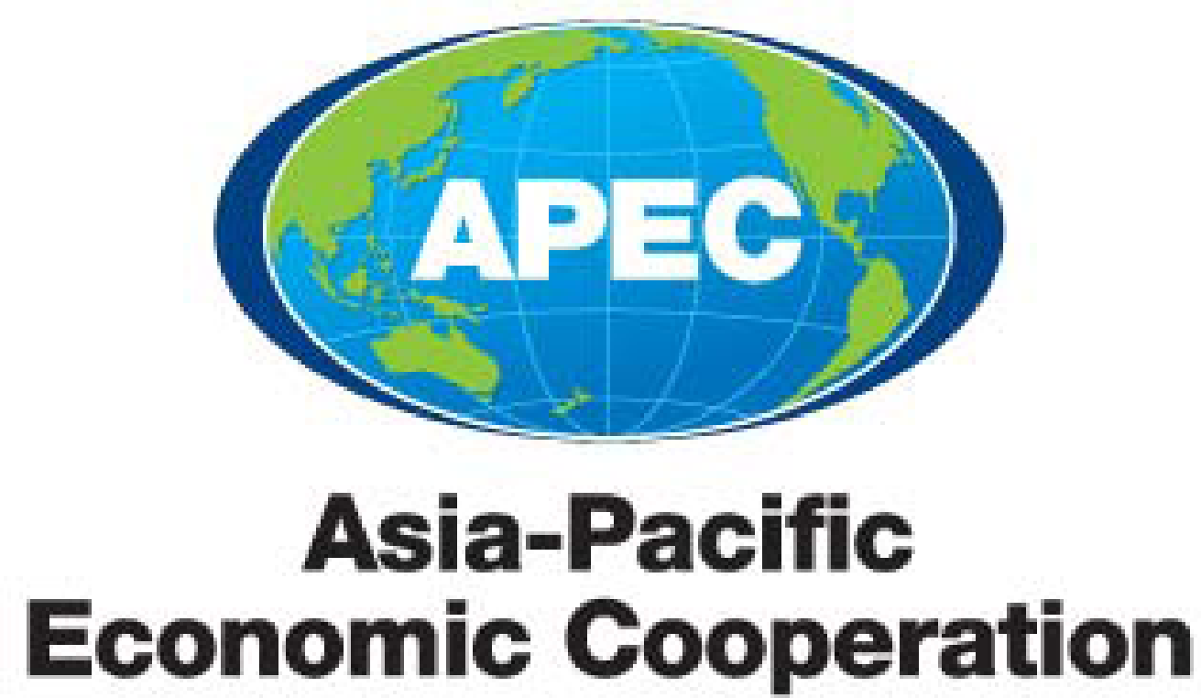

PPFS Work Plan 2021

Purpose: consideration and comment
Submitted by: PPFS Chair
APEC Policy Partnership on Food Security (PPFS)
Work Plan 2021

APEC Policy Partnership on Food Security (PPFS)

Workplan for 2021

Introduction

- In 2021, PPFS will continue to work on initiatives and projects to strengthen regional food security, work towards a sustainable and inclusive food system and address the challenges posed by the COVID-19 pandemic.

- Building on the APEC 2021 theme Join, Work, Grow. Together Haumi ē, Hui ē, Tāiki ē, PPFS will develop the Food Security Roadmap Towards 2030 to ensure the key challenges facing the region on food security are addressed, including incorporating high level goals, strategies and objectives to ensure economies are resilient to future pandemics and other traumas.

- PPFS acknowledges the importance of the private sector in the food sector and their role in food security. PPFS will focus on promoting public-private partnerships and investments to ensure greater resilience in the food systems and ABAC’s recommendations for a whole-of-system approach for food production.

- This work is in line with the APEC Putrajaya Vision 2040 (the successor of the Bogor Goals from 1994) of “an open, dynamic, resilient and peaceful Asia-Pacific community by 2040, for the prosperity of all our people and future generations”. The initiatives and projects will be performed in collaboration with the United Nations, its agencies and other relevant international and regional organisations and consistent with World Trade Organization (WTO) commitments.

APEC Priorities for 2021

- APEC Food Security Roadmap Towards 2030

The Food Security Roadmap is an important guiding document for APEC member economies. In 2021 New Zealand will lead the development of a new food security roadmap to replace the APEC Food Security Road Map Towards 2020.

The COVID-19 crisis has impacted food security regionally and globally by disrupting supply chains and affecting food production. The region’s food systems were already facing significant challenges in terms of population growth, urbanisation, climate change, the depletion of natural resources, and new technological developments that are expected to transform the sector.

The new Roadmap will assist economies in responding to food security challenges, establish objectives and incorporate high-level strategies. It will also set out the implementation strategies for goals within the respective Working Groups. The process will be conducted virtually with the following timetable:

Date | Event | Action
2-3 March 2021 | PPFS Plenary Meeting One | Endorsement of the Roadmap Terms of Reference, keynote speeches and a high-level panel discussion on the vision for Roadmap 2030
April/May 2021 | Intersessional Webinars (1.5 hrs each) on key elements for APEC Food Security Roadmap Towards 2030 | Key elements of Roadmap 2030 are examined and discussed over the four sessions:  - Building in resilience in the APEC food system to stress, shocks and strains  - Encouraging an inclusive food system for SMEs, women and indigenous, peoples, including ways for these groups to lead on food security efforts in their economies  - Increasing productivity, efficiency and innovation  - SMART goals and tracking effective implementation
May-August 2021 | Small working group (Chaired by PPFS Chair) of interested economies, including public and private sector representatives | Two drafting sessions and three drafts of Roadmap 2030 circulated to all economies
August 2021 | PPFS2 2 August | Substantive public/private sector discussion on Roadmap 2030. Draft agreed on final text for Roadmap 2030
TBC | Food Security Ministerial Meeting | High Level Policy Dialogue and endorsement of new APEC Food Security Roadmap

- Private Sector Participation in PPFS
A priority for PPFS is increasing quality private sector engagement, considering its contribution to enhancing food security. While policymakers take the lead in developing policy, without the input of primary producers, processors, distributors and import/exporters; the food system would not function. For this reason, PPFS will be seeking the enhanced involvement of the private sector in the development of Roadmap 2030 to ensure an innovative refreshed food system to meet food security challenges of the future, acknowledging also the valuable role and inputs of ABAC as Vice Chair of PPFS.

Expected Outcomes / Deliverables

- Completion of Food Security Roadmap Towards 2030
- PPFS Plenary Meeting One; 2-3 March 2021
- PPFS Plenary Meeting Two; 2 August 2021
- Food Security Ministerial Meeting; date TBC

Virtual PPFS Plenary Meetings

Event | Date / Format
Policy Partnership for Food Security (PPFS) Plenary Meeting 1 | 2-3 March 2021  - 2 sessions (2-3hrs each)
Drafting sessions for PPFS Ministerial Statement | July  - 2-3 sessions, one per week
PPFS Plenary Meeting 2 | August  - 2 sessions (2-3hrs each)
Food Security Ministerial Meeting | TBC

Other Virtual PPFS Related 2021 Activities of Members

Workshops

Services and the Food System | 13-16 April  - 4 sessions (3x3hrs, 1x2.5hrs) over 4 consecutive days
APEC-Global Research Alliance Virtual Farm Study Tour | Launch week of 12th April 2021 (tentative)  - 1 panel discussion session (2 hrs) on a Thurs or Fri
Capacity-building Workshop on Implementation of Port State Measures under the APEC Roadmap on Combatting Illegal Unreported and Unregulated Fishing | June 2021  - 2 sessions (2hrs each) over 2 consecutive days
APEC Workshop on Reducing Food Loss and Waste along the Food Value Chain in APEC During and Post COVID-19 Pandemic | June 2021  - 2 sessions (3hrs each) over 2 consecutive days
APEC-GRA Joint Workshop on E6nhancing Livestock GHG Inventory Methodology | September 2021 (date TBC)  - 3 sessions (2-3hrs each) over three consecutive days
E-commerce Opportunities and Ethnic Minorities: Bringing Innovation, Expanding Markets and Unleashing Potential | October 2021  - 3 sessions (3hrs each) over three non-consecutive days
Workshop on promotion of healthy diets and information sharing on Food Security（TBC） | October 2021(date TBC)

PPFS Working Group Workplans
Attachment A
- Working Group One

PPFS Joint Meetings
Meeting with Policy Partnership on Women & the Economy (TBC)

Fora Assessment, ToR and Mandate Review
The PPFS has a term of four years starting from 2018. At the expiration of this and any subsequent term, the mandate of PPFS and its Terms of Reference shall be reviewed by the PPFS and a recommendation on renewal put to Senior Officials for approval. In 2021, the PPFS is required to undertake this review.

Related Initiatives of Other APEC Fora
ATCWG
- APEC-Global Research Alliance Virtual Farm Study Tour (Self-funded by New Zealand, to be launched in the week of 12 April 2020)
- APEC Workshop on Reducing Food Loss and Waste along the Food Value Chain in APEC During and Post COVID-19 Pandemic (Funded by APEC, to be hosted by Chinese Taipei in June 2021)
- APEC-GRA Joint Workshop on Enhancing Livestock GHG Inventory Methodology (Self-funded by New Zealand, date TBC)
- APEC Workshop on Practices and Promotion of Circular Agriculture (Funded by APEC, to be hosted by Chinese Taipei, date TBC)

