Version Jan 28, 2016

**Draft Roadmap to Promote**

**Good Registration Management (GRM)**

Lead Economy: Chinese Taipei, Japan

Contact:

(Chinese Taipei) 1) Ms. Li-Ling Liu, Researcher, Food and Drug Administration, Ministry of Health and Welfare. Email: [LLL@fda.gov.tw](mailto:LLL@fda.gov.tw)

2) Ms. Chyn-Liang Huang, Section Chief, Division of Medicinal Products, Food and Drug Administration, Ministry of Health and Welfare. Email: clhuang@fda.gov.tw

3) Dr. Hsien-Yi Lin, Senior Reviewer, Division of Medicinal Products, Food and Drug Administration, Ministry of Health and Welfare. Email: hsienyilin@fda.gov.tw

(Japan) 1) Dr Nobumasa Nakashima, International Planning Director, Ministry of Health, Labour and Welfare (MHLW). Email: nakashima-nobumasa@mhlw.go.jp

2) Dr Toshiyoshi Tominaga, Associate Executive Director (for International Programs), Pharmaceuticals and Medical Devices Agency (PMDA). Email: tominaga-toshiyoshi@pmda.go.jp

3) Dr Junko Sato, Office Director, Office of International Cooperation, Pharmaceuticals and Medical Devices Agency (PMDA). Email: sato-junko@pmda.go.jp

**Goal of Topic:**

* The goal of this roadmap is to promote the concept of Good Registration Management (GRM, Fig 1)* and thereby enhance mutual trust for regulatory convergence* among the APEC economies by 2020. It can be realized by promoting the key elements of GRM, i.e. Good Review Practice (GRevP)* and Good Submission Practice (GSubP)*, cooperatively.
* The goal of each key element is as follows:

**GRevP:**

* To strengthen the performance, predictability, and transparency of regulatory agencies through the implementation or enhancement of Good Review Practices (GRevP) and quality measures stepwise in each interested APEC economy.

**GSubP:**

* To enhance the quality and efficiency of the medical product registration process by improving the quality of submission as well as its management.

**Fig. 1** Concept of GRM

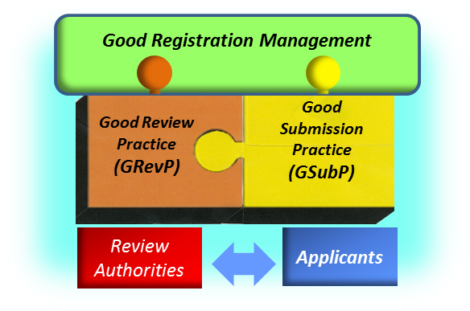

|  |
| --- |
| **\*Glossary**  ***GRM:*** *A concept to promote efficient registration process for medical products by promoting Good Review Practice (GRevP) and Good Submission Practice (GSubP) cooperatively.*  ***GRevP:*** *Documented best practices for any aspect related to the process, format, content and management of a medical product review.*  ***GSubP:*** *An industry practice for any aspect related to the process, format, contents and management of submission for registration of medical products by applicants.*  ***Regulatory Convergence:*** *Represents process whereby regulatory requirements across economies become more aligned over time as a result of the adoption of internationally recognized technical guidance, standards and best practices* |

**Introductory section on background and challenges:**

* “Regulatory convergence” has been a priority of APEC Life Sciences Innovation Forum (LSIF) for needed patients to have early access to innovative medical products. The Regulatory Harmonization Steering Committee (RHSC) was established in 2009 to set up a strategic framework for regulatory convergence with the objectives of creating synergies, avoiding duplication of efforts, and setting up a roadmap for stepwise implementation.
* GRM is the concept to promote both GRevP by regulators and GSubP by industry cooperatively and thereby enhance the quality and efficiency of the medical product registration process. The implementation of GRM concept and its key elements, GRevP and GSubP, based on the best international practices would be an essential basis for enhancing regulatory convergence among APEC economies.
* The topic was adopted as a combined topic of GRevP and GSubP in APEC LISF RHSC in 2015.
* In June of 2010, Chinese Taipei, with support from APEC LSIF, held an international GRevP workshop on medical device entitled “APEC Regulatory Harmonization on Medical Devices – Good Review Practices: A Key Enabler in Promoting Quality Decision-Making”. A similar workshop was held in November in Taipei for GRevP of pharmaceuticals. These introductory workshops brought together representatives from various APEC economies to address the fundamental elements of a well-designed regulatory review system and served as a gateway for the implementation of GRevP in each APEC economy. As part of the implementation of the 2020 Good Review Practices (GRevP) Roadmap, Chinese Taipei organized 2 workshops entitled “2011 APEC Good Review Practice Workshop on Medical Products” and “2012 APEC Advanced Workshop of Good Review Practice on Medical Products” respectively. The purpose of these workshops was to address the fundamental elements of a well-designed regulatory review system, to provide complementary modules for GRevP and approaches to the exchange and the use of product assessment reports between regulatory authorities, and to further promote regulatory efficiencies and best practices. The workshops brought together 81 regulatory representatives from 15 economies for the basic workshop and 133 from 20 economies for the advanced workshop. Participants forged a common understanding of GRevP and highlighted its importance. While the adoption of GRevP is key to building trust between agencies, each economy should address its needs and adopt its own best practices based on its resources and environment. The outcomes of these workshops were used as a framework for the development of a GRevP best-practice document entitled “Good review practices: guidelines for national and regional regulatory authorities”, which was published by the World Health Organization (WHO) in 2015. They could also serve as materials for further training in each economy or offered by the APEC Training Centers of Excellence for Regulatory Science.
* In October of 2014, Chinese Taipei held the first International Forum on GSubP and shared basic concept and experiences of GSubP among stakeholders. In February 2015, Asia Regulatory Conference was held in Taipei entitled “Advancing Best Practices for Regulatory Review and Submission in Asia”. It was co-organized by Chinese Taipei, APEC, IFPMA and other industry stakeholders - See more at: <http://www.ifpma.org/quality/regulatory-conferences/asia-regulatory-conference.html>. A panel discussion session was held to have in-depth discussions on significance and future direction of GSubP. The outline of GSubP guideline was proposed by APAC in these forum and workshop to facilitate discussions. A similar workshop was hosted by Chinese Taipei in September 2015 for GSubP of pharmaceuticals – See more at: <http://edu.tcfst.org.tw/edm/gsp/GSP.html>. The objectives of this workshop were not only to share experiences and discuss the approaches to promote and implement GSubP, but also to discuss the development of core curriculum for training on GRevP and GSubP. These introductory workshops served as a gateway for the dissemination and implementation of GRevP and GSubP in APEC region.
* The background and challenges of GRevP and GSubP are summarized as follows:

**GRevP:**

* + - The activity to promote GRevP was initiated in 2011 under “2020 Roadmap for GRevP on Medical Products.” GRevP needs to comply with the existing local, legal, administrative requirements of a particular APEC economy. Under the concept of regulatory convergence, it is expected and acceptable to have different regulatory approaches, as long as it contains the spirit of all the essential components, in achieving the same goal. Currently, there is a lack of conformity on GRevP for medical products among APEC economies, as each economy has different levels of sophistication and approaches for GRevP. The stepwise implementation of the essential elements of GRevP based on the best international practices would be an essential basis for enhancing regulatory convergence among APEC economies. This should enhance domestic regulatory performance, predictability, and transparency, and support the exchange of regulatory information to leverage the limited regulatory resources among regulatory agencies.
    - In addition, a new challenge for the registration of medical products in APEC economies is the emergence of new medical products, including high-tech medical devices and more targeted biologic drugs with various new and novel intended clinical uses. The rapid development of these products poses uncertainties, which calls for new risk and benefit considerations. Therefore, in order to allow early access of innovative medical products by patients across borders, it is imperative to set up GRevP via this roadmap.

**GSubP:**

* + - The activity to promote GSubP was initiated in 2013 by APAC (Asia Partnership Conference of Pharmaceutical Associations). The purpose of this practice is to enhance the quality and efficiency of the product registration process by improving the quality of submission as well as its management. It is expected that promotion of GSubP together with GRevP under the proposed concept of GRM would create synergic effects in enhancing quality and efficiency of medical product registration process and thereby lead to regulatory convergence among APEC economies.
    - Since standardization of submission practices has not been undertaken in the APEC region, the need of sharing the GSubP concept and significance have been fully recognized and understood among APEC economies. It is believed that the stepwise implementation of the essential elements of GSubP based on the best international practices would be a basis for promoting GRM and enhancing regulatory convergence among APEC economies.

**Gap Analysis**

* The current challenge lies in that various economies have different levels of sophistication and approach of GRevP and GSubP. Summaries of gap analysis and challenges for GRevP and GSubP are as follows:

**GRevP:**

* + - As a first step in the implementation of the APEC Best Regulatory Practice Project, the Centre for Innovation in Regulatory Science (CIRS) conducted a gap analysis survey among regulatory agencies of 14 APEC member economies to assess the current use of GRevP to support transparent, consistent, predictable, and good-quality regulatory decision making in 2011 and 2012 2. Although the majority of responding agencies have established some form of GRevP, most practices are currently evolving and are applied on an informal basis. Most agencies have developed standard operating procedures and guidelines and use a variety of training methods. The use of a common approach to regulatory review across jurisdictions would help build trust and confidence in each agency’s processes, setting the stage for the possibility of work sharing across resource-constrained agencies and bringing consistency and transparency to the review process.

**GSubP:**

* + - Currently, industry sectors in each economy have different levels and approaches of submission. Several articles provided survey results on the practices of GRevP and addressed the issue of quality of application submissions by applicants. For examples:

In 2006, US-FDA issued “Independent Evaluation of FDA’s First Cycle Review Performance –Retrospective Analysis Final Report” 1. In this document, it was noted that application quality and communication emerged as having significant influence on the FDA first cycle review performance. It also identified that unfamiliarity with FDA regulations and the drug application process is a key problem for inexperienced sponsors and results in poor quality submissions.

In the aforementioned report of GRevP gap analysis conducted by CIRS, it was indicated that comparatively fewer agencies have discussions with sponsors with the goal of improving the quality of submissions. Issue of quality of application dossier was also addressed in an R&D briefing report by CMR International in 2006 3. The report described key elements of a quality dossier and provided feedback from regulatory agency on company performance of applications.

These reports as well as the gap analysis conducted for GRevP under the APEC RHSC indicate necessity of promotion of GSubP by applicants in conjunction with promotion of GRevP by regulatory authorities to improve quality and efficiency of product registration process.

1 Independent Evaluation of FDA’s First Cycle Review Performance –Retrospective Analysis Final Report. January 2006 (by Booz Allen Hamilton Inc.)

2 Characterizing Good Review Practices: A Survey Report Among Agencies of APEC Member Economies. Therapeutic Innovation & Regulatory Science 47(6) 678-683, 2013.

3  Building Quality into Regulatory Activities: What does it mean? June 2006 (by CMR International)

**Specific activities and time frames：**

* The outline of GRM roadmap is as follows:

**Fig. 2** 2020Roadmap to Promote GRM in APEC region



* + - **Step 1 (2011-2012) – Gap Analysis Survey for Setting the Foundation for Stepwise GRevP Implementation**

1. Set up a technical working group:
   * + - * To forge a common understanding of GRevPs, as well as to promote its importance and appreciation of this topic as a recognized discipline, a technical working group has been set up under the RHSC to facilitate implementation of GRevP. Its goals include analyzing survey results to identify gaps, prioritizing needs and activities, setting up training programs and evaluating the effectiveness of their implementation.
       1. Gap analysis survey for APEC economies:
          - To begin implementing the process of GRevP, it is essential to first identify the differences in regulatory capacity, current status of the essential elements of GRevP, and prioritize areas for improvement. A gap analysis survey of GRevP for medical products within APEC economies was conducted by CIRS in 2011 and 2012. The completed results were published in Therapeutic Innovation & Regulatory Science (Liu et al., Characterizing Good Review Practices: A Survey Report Among Agencies of APEC Member Economies. Therapeutic Innovation & Regulatory Science November 2013 47: 678-683, first published on July 19, 2013).
       2. Prioritize needs and strategy for improvement based on the result of the gap analysis survey:
          - Analyze the survey:

Revise the working definition of GRevP based on the existing GRevP definition of some APEC economies collected from the survey and feedbacks from others.

Further define the essential elements of GRevP based on the best international practice.

Group possible GRevP approaches in various resource setting.

Strategies for implementation.

Recommendation for competence-based training for regulators.

* + - * + Review template sharing:

Set up repository of review templates.

Analyze the common elements/attributes of the review templates.

* + - * + Summarize comments on the advantage and concerns for regulatory information exchange and sharing.
    - **Step 2 (2011-2016) – Planned Solution to Address Gap in GRM**
      1. Training: workshops and CoE Training Programs

**GRevP (2011-2012):**

* + - * + Set up format and content of basic and advanced training workshops:

Format: It was a small group closed door workshop targeting the training of regulators. The basic training workshop included an open session to communicate the progress of GRevP to all stakeholders.

Content: Experienced speakers from regulatory agencies, industrial association and academia were invited. Structured case studies were offered with mentors. Candid discussion and experience sharing among regulators were encouraged.

* + - * + Workshops completed:

2011: basic training workshop in Chinese Taipei

2012: advanced training workshop in Chinese Taipei

**GRM (2016):**

* + - * + Training to be developed:

A GRM CoE Pilot Training Program including GRevP and GSubP is being planned for late 2016 in Chinese Taipei. Outcomes of this Pilot Training Program will be evaluated to formulate a sustainable training curriculum for the GRM CoE.

* + - 1. Develop normative GRevP/GSubP documents:

**GRevP (2013-2015):**

* + - * + The draft of “Good review practices: guidelines for national and regional regulatory authorities” was developed by an RHSC working group in collaboration with WHO in 2013 and 2014. This document was adopted by WHO Expert Committee on Specifications for Pharmaceutical Preparations in October 2014 and published on the WHO website <http://www.who.int/medicines/areas/quality_safety/quality_assurance/Annex9-TRS992.pdf?ua=1> in 2015.

**GSubP (2015-2016):**

* + - * + The Draft of “Good submission practice (GSubP): guideline for applicants” was developed by APAC and is under review by APEC RHSC and WHO. It is planned to obtain endorsement of APEC in 2016.
      1. Dissemination of GRevP, GSubP and GRM (2014-2016):
         * Dissemination of GRevP, GSubP and GRM are through national/international conferences and workshops. The topics were presented in the following conferences and workshops:

**GRevP:**

RAPS’ Regulatory Convergence, Austin, United States, September 2014

IPRF Meeting, Lisbon, Portugal, November 2014

**GSubP:**

National Regulatory Conference 2015. in Petaling Jaya, Malaysia, August 2015

The 1st Thailand Pharmaceutical Medicine Conference. in Bangkok, Thailand August 2015

2015 International Good Submission Practice Workshop on Pharmaceuticals, Taipei, Chinese Taipei, September 2015

The workshop of Drug Registration. in Jakarta, Indonesia, December 2015

**GRM:**

8th Asia Regulatory Conference, Taipei, Chinese Taipei, February 2015

* + - 1. Establish a network of GRevP and a network of GSubP:
         * The networks may include experts, alumni for target review disciplines, and competent organizations such as CIRS, Food and Drug Alumni Association (FDAAA), and Regulatory Affairs Professionals Society (RAPS).
    - **Step 3 (2017-2019): Assessing the Impact of GRM**
      1. Training on GRevP, GSubP and GRM
         * Initiate the training of trainers for reviewers and applicants. After confirming the feasibility of the training curriculum, extend the CoE training program to full-scale, continue assessing the outcomes of training, and evaluate the impact of implementation of GRevP and GSubP in each economy.
      2. Dissemination of GRevP, GSubP and GRM (continued)
         * Continue dissemination activity of GRevP, GSubP and GRM through national/international conferences and workshops.
    - **Step 4 (2018-2020): Reaching the Goal for Implementing GRM**
      1. Follow-up Measures and Final Assessment
         * Take follow-up measures according to the outcome of annual assessment conducted in Step 3.
         * Conduct final assessment and prepare a final assessment report for the outcomes of the GRM roadmap.
* The main activity after Step 2, starting from 2015, in the roadmap is to promote implementation of GRM through trainings. The proposed structure of GRM training consists of 3 modules, i.e. “Common Training”, “Reviewer Specific GRevP Training” and “Applicant Specific GSubP Training” (Fig 3). The “Common Training” module consists of 1) Basic Concept of GRM, 2) Outline of GRevP Guideline and 3) Outline of GSubP Guideline. It will be incorporated into the training program for both reviewers and applicants so that they can acquire holistic understanding of GRM and fundamentals of GRevP and GSubP as the basis of practical training.

**Fig. 3** Proposed Structure of GRM Training

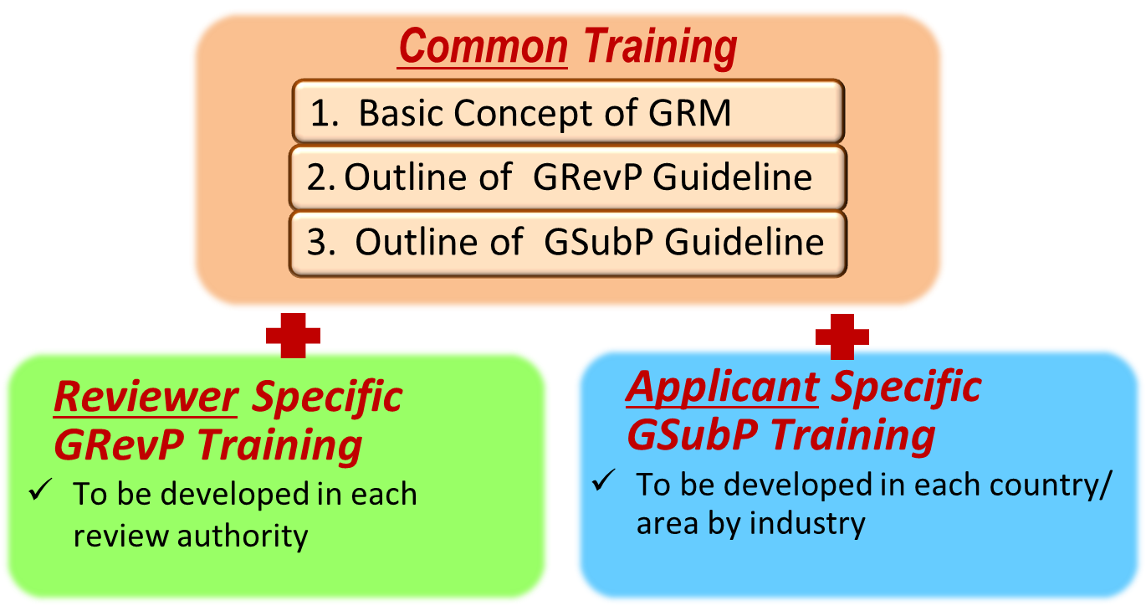

* The “Train-the-Trainer” model will be adopted to facilitate the whole process of the training program. Trainers from regulatory authorities and industry sectors in each APEC economy are invited to participate in the trainers’ training at CoE. The trained and qualified trainer will conduct training for reviewers and applicants in his/her party.
* The GRM CoE(s) will be established, and a CoE pilot is planned in late 2016 as the first step of the GRM training program. Curriculum and materials for training reviewers and applicants will be developed in cooperation with the GRM CoE.
* Based on the outcomes of the CoE pilot, the curriculum and materials will be revised and/or customized as necessary and used for the training of reviewers and applicants. The training program will be adjusted based on the outcome of annual assessment accordingly.
* The GRevP and GSubP trainings in this roadmap will be initially applied to the new pharmaceutical products. The trainings will be applied to other medical products stepwise.

**Performance Indicators**

* This roadmap serves to promote the implementation or enhancement of GRM in a stepwise process for each interested APEC economy. Based on the needs of each economy, different measures may be taken to reach the same goal; therefore, in accordance to step 3 of the GRevP and GSubP roadmaps, performance indicators should be examined to assess the effectiveness of this roadmap in promoting GRM.
* Overall progress of GRM topic will be evaluated periodically and comprehensively based on the key performance indicators defined for each GRevP and GSubP as follows:

**GRevP:**

* **Roadmap Outputs**

Below is a checklist of deliverables upon the successful completion of this roadmap:

1. Good review practices: guidelines for national and regional regulatory authorities. WHO Technical Report Series, No. 992, 2015, Annex 9
2. Materials and reports from “2011 APEC Good Review Practice Workshop on Medical Products” and “2012 APEC Advanced Workshop of Good Review Practice on Medical Products”
3. Training curriculum and materials or e-learning targeting on training of regulators
4. Related documents based on each step of the roadmap, including gap analysis survey reports, final assessment survey report, and progress reports
5. Final assessment report on the impact of this roadmap in promoting GRevP

* **Measurable Outcomes**

*Reviewer Competency and Training*

- Implementation of technical training programs and soft skills training

- Number of training certificates issued for qualified trainers

- Number of training certificates for regulators

*Use of Templates and Procedures*

Number of SOPs and templates available

Degree of adherence required for following SOP

*Transparency, Consistency, Predictability and Timeliness*

Number/ Type of information accessible by public online

Involvement of stakeholders

Establish checkpoints and set target timelines for review, and determine how many reviews have met these targets

Adoption of peer review

Establishment of a quality system

**GSubP:**

* **Roadmap Outputs**

Below is a checklist of deliverables upon the successful completion of this roadmap:

1. GSubP Guideline Document for Applicants
2. Training curriculum and materials or e-learning targeting on training of applicants
3. Trainer’s manual or handbook (Instructions for trainers on how to conduct training for applicants)
4. Related documents based on each step of the roadmap such as survey report and progress report
5. Final assessment reports on the impact of this roadmap in promoting GSubP

* **Measurable Outcomes**
* *Applicants Competency and Training*

- Implementation of technical training programs and soft skills training

- Number of training certificates issued for qualified trainers

- Number of training certificates for applicants

*Quality of Submission (potential evaluation item)*

Number of major deficiencies/rejection at filing

Number of SOPs and templates available

Degree of adherence to each item of the principles of good submission

**Relevant Guidelines to be provided:**

* Good Submission Practice (GSubP) Guideline Document for Applicants
* Good review practices: guidelines for national and regional regulatory authorities. WHO Technical Report Series, No. 992, 2015, Annex 9

<http://www.who.int/medicines/areas/quality_safety/quality_assurance/Annex9-TRS992.pdf?ua=1>