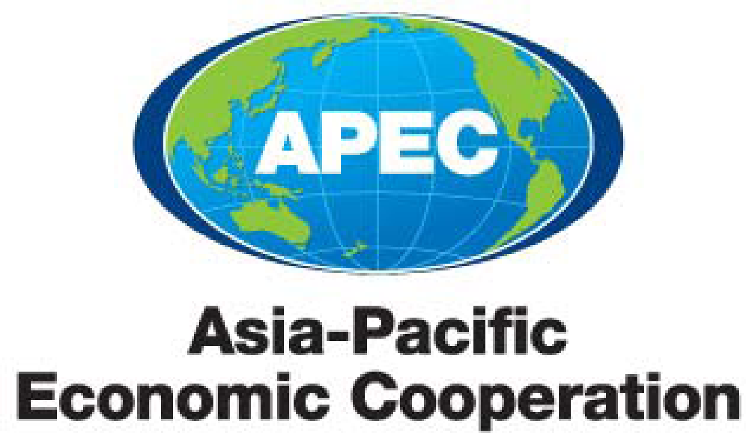

APEC High Level Policy Dialogue on Agricultural Biotechnology (HLPDAB)
Work Plan 2021

Purpose: consideration and comment
Submitted by: HLPDAB Chair

APEC High Level Policy Dialogue on Agricultural Biotechnology (HLPBAD)

Workplan for 2021

1. Introduction
In 2021, the High Level Policy Dialogue on Agricultural Biotechnology (HLPDAB) will conduct a sequence of activities that aim to respond to APEC Leaders’ Declarations, Ministerial and High-Level statements, decisions of Senior Officials and, where appropriate, APEC Business Advisory Council (ABAC) recommendations. The HLPDAB will continue to implement the Nigata Declaration on APEC Food Security (2010), the Kazan Declaration on APEC Food Security (2012), the Beijing Declaration on APEC Food Security (2014), the Piura Declaration on APEC Food Security (2016), the Can Tho Statement on Enhancing Food Security and Sustainable Agriculture in Response to Climate Change (2017), and Papua New Guinea Dialogue Summary (2018), Puerta Varas Declaration Towards Integrated Smart and Sustainable Food System (2019).

The proposed activities to be taken sit within the framework of the HLPDAB Strategic Plan (2019-2021), which focuses on three priority areas:
- Establish main mechanisms to ensure continued information exchange on economies’ experience with agricultural biotechnology and other innovative agricultural technologies.
- Promote transparent, science-based and functioning regulatory systems to support the development, application and trade of innovative agricultural technologies and biotechnologies for the benefit of APEC member economies.
- Facilitate the management of regulatory differences by endeavoring to develop solutions to global challenges with respect to innovative agricultural technologies—including trade-related issues—and improve the ability of APEC economies to communicate effectively about these issues

2. Key takeaways from the 19th HLPDAB Meeting, 8 October 2020
- Products of innovative and emerging agricultural biotechnologies will play a vital role in supporting sustainable agriculture production by addressing environmental, pest and disease pressures, and food security challenges facing APEC Economies.
- To fully realize the innovative and emerging agricultural biotechnology initiatives, APEC Economies should support agricultural biotechnology initiatives focused on capacity building, regulatory cooperation, science communication to strengthen public confidence, promote food security, enhance environmental sustainability, and spur economic growth through innovation and trade.
- Economies are encouraged to develop and maintain transparent, predictable, science-based, and risk-proportionate regulations that facilitate trade and promote trust in the safety of products derived from innovative and emerging agricultural biotechnologies.
- Economies are encouraged to enhance cooperation to facilitate the management of regulatory differences related to precision and innovative biotechnology products, including through sharing information and exploring opportunities for regulatory harmonization or mutual recognition where possible.

2. HLPDAB Activities
2.1 Annual HLPDAB Meeting
HLPDAB will hold a Virtual Annual Plenary Meeting on 3 August 2021 to continue addressing its mandate to exchange information and promote capacity building, to promote transparent, science-based, and functioning regulatory systems, to encourage investment and strengthen public confidence regarding biotechnology with the ultimate objective of promoting food security in line with HLPDAB Strategic Plan (2019-2021). This will be run as a three-hour session.
The annual meeting will continue building relationships among APEC members while exchanging information regarding the responsible use, development, and adoption of innovative agricultural biotechnologies, with some emphasis on use of genomic tools to meet agricultural challenges and environmental sustainability.

2.2 HLPDAB 2021 Workshops
Workshop | Date
United States - HLPDAB 03 2021S: Building Regulatory Capacities for Biotechnology (Genetic Engineering) | 27-28 April
United States - HLPDAB 02 2021S: Building Regulatory Capacities for Biotechnology (Genome Editing) | 29 -30 June, 8:00 AM – 11:00 AM MYT; 28 -29 June, 8:00 PM – 11:00 PM EDT
United States - HLPDAB 01 2021S: Building Effective Communication Strategies on Agricultural Biotechnology Webinar Series | Webinar I: 9 -10 June 8:00AM-11:00 AM MYT; 8 - 9 June 8:00 PM-11:00PM EDT  Webinar II: 23 - 24 June 8:00AM-11:00AM MYT; 22 - 23 June 8:00-11:00 PM EDT
United States – HLPDAB 04 2021S: Harnessing 25 years of agricultural biotech experiences: Policy approaches to promote the adoption, commercialization, and trade of innovative agricultural technologies | July  3 days  (TBD)

3. Expected Outcomes/Deliverables for 2021

No | Expected outcomes | Deadline
1 | Continue promotion of transparent and science-based regulations to promote agricultural biotechnology and innovation in the context of global trade | Ongoing
2 | Continue to enhance understanding and share information on development of innovative and biotechnological methods and products to help address food security and meet environmental challenges | Ongoing
3 | Continue to promote understanding, best practices and confidence in APEC economy regulatory  systems | Ongoing
4 | Continue to develop self-funded capacity building proposals and proposals for APEC-funded projects | Ongoing
5 | Facilitate collaboration across APEC sub-fora on food security issues | Ongoing
6 | Contribute to enhancement of the scientific knowledge of APEC economy regulators and policy makers | Ongoing
7 | Engage ABAC, private sector, and other relevant non-members to promote the work of HLPDAB, as appropriate | Ongoing
8 | Preparation of HLPDAB inputs for the APEC Ministerial Meeting on Food Security 2021 | Aug

4. Fora Assessment, ToR and Mandate Review
The HLPDAB has a term of four years starting from 2018. At the expiration of this and any subsequent term, the mandate of HLPDAB and its Terms of Reference shall be reviewed by the HLPDAB and a recommendation on renewal put to Senior Officials for approval. In 2021, the HLPDAB is required to undertake this review.

