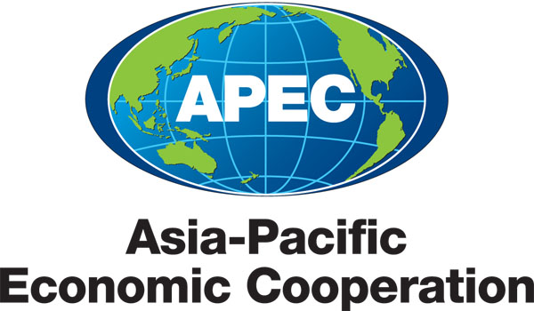
___________________________________________________________________________
2018/SOM1/PL

Participant List

Purpose: Information
Submitted by: APEC Secretariat

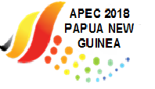 |  | First Senior Officials’ Meeting  Port Moresby, Papua New Guinea  8-9 March 2018

Participant List

S/N | Economy or Entity where applicable | Title | Name | Position | Organisation | Email | Gender

Please use the following sequence:

Australia
Brunei Darussalam
Canada
Chile
China
Hong Kong, China
Indonesia
Japan
Korea
Malaysia
Mexico
New Zealand
Papua New Guinea
Peru
Philippines
Russia
Singapore
Chinese Taipei
Thailand
United States
Viet Nam
APEC Secretariat
ABAC
ASEAN
PECC
PIF
Invited Guests

