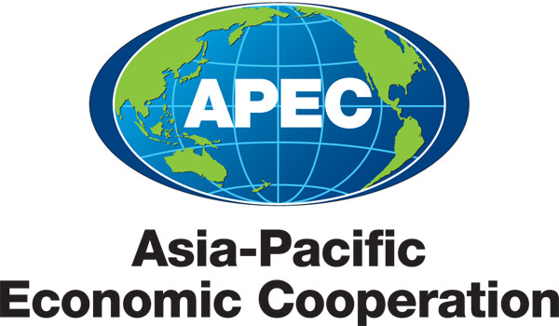 Applying for APEC Funds

Summary Sheet

Projects help translate APEC Ministers' and Economic Leaders' policy directions into actions, and create tangible benefits for people living in the Asia-Pacific region. This document provides an overview of the process. Please consult the Guidebook on APEC Projects for detailed information.

Who can apply for APEC funds?
- A project originates from an APEC economy (or economies) and is proposed through an APEC forum. The proposing economy will lead the design and delivery of the project through the Project Overseer (PO), who coordinates the project during approval and implementation phases.

When are project approval sessions?
- APEC has three submission deadlines per year, by which a 3-page Concept Note must be submitted. Check the APEC website or your Program Director for current approval session dates.

What types of projects does APEC fund?
- Most projects involve seminars, workshops, meetings, research projects and/or publications.
- Projects must represent a priority for the proposing forum and for broader APEC agendas.
- Themes include: trade facilitation, energy, standards & regulation, health, anti-corruption etc.
- Standard projects must be completed within two financial years.
- APEC has launched a Multi-Year Projects limited pilot program, for strategic 3 to 5 year projects.

What are the sources of funding for APEC projects?
- Operational Account (OA: for any general projects)
- Trade and Investment Liberalisation and Facilitation Account (TILF: only for projects that support the Osaka Action Agenda’s trade liberalization and facilitation aims)
- APEC Support Fund (ASF: for projects that support capacity building for developing economies), including General Fund and sub-funds: Energy Efficiency; ANSSR (Structural Reform); Science/ Technology; Health/Emergency Preparedness/Human Security; Trade Facilitation Action Plan II
- All funds are sourced from members’ contributions. POs select OA, ASF or TILF when applying

How are projects approved for funding?
- Below is a brief overview of the project process. See the Guidebook on APEC Projects, Ch.4.

PO discusses their idea with their APEC fora and relevant Program Director
▼

PO submits a three-page concept note describing the project’s relevance and plan
▼
At least two other economies agree to serve as co-sponsors and the
forum endorses and prioritises concept note/s
▼
Committees/SFOM use 2012 APEC Funding Criteria to rank and prioritise CNs overall
▼
Concept notes are approved for funding starting with highest priority,
until available funds are depleted
▼
PO expands concept note into full proposal and works with Secretariat until satisfactory
▼
Proposals recommended to BMC or SOM for approval

For more information or resources, please consult:

Guidebook on APEC Projects (Ed. 8.0), APEC website http://www.apec.org/Projects.aspx

