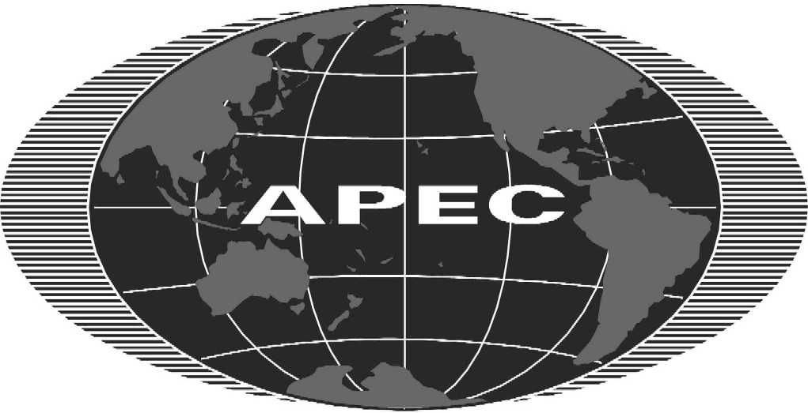

Asia-Pacific Economic Cooperation

2001/SOMII/CTI/051

Agenda Item No. 5(b)

Minutes of the Informal Meeting of CTI on the Terms of Reference of the Chemical Dialogue

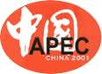
Committee on Trade & Investment

Senior Officials’ Meeting II

Shenzhen, People’s Republic of China
30-31 May 2001
INFORMAL MEETING OF THE CTI ON THE TERMS OF REFERENCE OF THE CHEMICAL DIALOGUE

Shenzhen, China

Meeting Minutes: 29 May 2001

- The Informal Meeting of the CTI on the Terms of Reference of the Chemical Dialogue was held in Shenzhen, China, 29 May 2001. The meeting was chaired by the United States and was attended by Australia, Canada, China, Hong Kong, China, Indonesia, Japan, Malaysia, Mexico, New Zealand, the Philippines, Singapore, Chinese Taipei, Thailand, and the United States.

- The meeting considered the Terms of Reference (TOR) for the Chemical Dialogue and, after some revision, approved the TOR for consideration by the Committee on Trade and Investment. The TOR is attached.

- As coordinator in APEC for the chemicals sector, the United States has offered to coordinate the Dialogue in cooperation with the host government in the initial stages.

- For the purpose of the inaugural meeting of the Dialogue in 2001, Mr. Ooi Chwee-kim, Chairman of the Singapore Chemical Industry Council, has agreed to offer his services as Co-Chair. Ms. Florie Liser, Assistant United States Trade Representative for Industry and Telecommunications has offered her services as the public sector Co-Chair for 2001.

The APEC Chemical Dialogue
Terms of Reference

1. The Mandate for the Dialogue

At the November 2000 Joint Ministerial Meeting in Brunei, Ministers “welcomed the initiative to establish a Chemical Dialogue comprising government and industry representatives” and said that “such public-private sector dialogues were important for improving the mutual understanding of key imperatives for the development of future policy and for enhancing the competitiveness of the industry.”

2. The Purpose of the Dialogue

2.1. The Chemical Dialogue is an exchange of views (conducted at a series of meetings) in accordance with the Ministerial mandate between private sector chemical industry representatives and appropriate government officials who are involved in developing trade and trade-related regulatory policy within APEC member economies. Accordingly, the Dialogue will discuss trade and trade-related regulatory issues affecting the competitiveness and sustainable development of the industry in the Asia-Pacific region. The Dialogue will progressively develop a work program according to priorities identified by industry and officials in the course of their joint discussions, which may focus on non-tariff measures, trade facilitation, and economic and technical cooperation related to the chemical industry in the Asia-Pacific region.

2.2. Based on these discussions, the Dialogue will develop recommendations to facilitate trade in the chemicals sector and enhance the competitiveness and sustainable development of the industry in the region. Some APEC Member Economies may choose to move more quickly than others in terms of implementing recommendations as is consistent with APEC’s flexible, voluntary and consensus oriented approach to trade facilitation and economic and technical cooperation.

3. The Structure of the Dialogue

3.1. The Dialogue will be held annually. The work program and outcomes of the Dialogue will be reported to the Committee on Trade and Investment (CTI) and, where appropriate, through the CTI to APEC Senior Officials, Ministers and Leaders. The work program and outcomes may also be conveyed to the APEC Business Advisory Council (ABAC) and other relevant APEC fora.

3.2. The Dialogue will be supported at the working level by a Steering Group, comprising private sector representatives and government officials. The Steering Group will meet as needed before the Dialogue, but not less than once a year, to define the agenda for the Dialogue, determine the schedule of meetings, and to facilitate the Dialogue. Schedules of meetings will be determined annually to allow flexibility. The proposed schedule of meetings in any one year, including the annual Dialogue meeting, will be agreed and deposited with the APEC Secretariat in a timely manner for inclusion in the APEC calendar.

3.3. The annual Dialogue will involve appropriate representatives of the chemical sector and of APEC member economies.

4. Administration of the Dialogue

4.1. The Dialogue will be Co-Chaired by a representative of the chemical industry and a representative from the public sector to coordinate private sector views and public sector positions. Co-Chairs would be selected by the Dialogue from a list provided by the Steering Group to serve for a term of up to two years.

4.2. To facilitate the work of the Co-Chairs of the Dialogue each member economy is invited to designate up to two contact points to coordinate that member economy’s participation in the Dialogue.

4.3. The names of the Co-Chairs and contact details will be deposited with the APEC Secretariat by the Dialogue coordinator.

